Signal 3
Fourier series - Periodic Signals 5
Fourier series - Complex coefficients form 5
Time frequency relationship 6
Fourier series - Sine/Cosine Form 7
Fourier series - Cosine only Form 8
Fourier series - Dirac Delta Form 8
Properties of Fourier Series 9
Extract coefficient from difficult signals 10
Transmission of Signal (Response) in a Linear System 1
Power of a periodic signal - Parseval theorem 1
Power spectral density G(f) (aka derivative of power) 1
Fourier transform - Aperiodic Signals 1
Comparison of fourier series with fourier transform 1
Properties of Fourier transform 1
Cosine Multiplication: Multiplexing in Frequency 1
Utility of Many Frequencies 1
Convolution 1
Energy E - (Parseval Theorem) - Spectral Energy Density 1
Energy through a Linear Block 1
Filters 1
Correlation 1
Correlation for delay calculation 1
Correlation and Power (Energy) - energy/power of the sum of two signals 1
Autocorrelation 1
Properties of autocorrelation 1
Autocorrelation of a Periodic Signal 1
⬇️_____________________________⬇️ 1
Random signals 1
Random Process 1
Random Process statistical indices 1
Stationary process - “time invariant” 1
⬆️ _____________________________ ⬆️ 1
Power spectral density Gx(f) of stationary signals 1
Noise 1
White noise 1
Sampling - Sampled Signal Sc(t) 1
Spectrum of Sampled Signal 1
Nyquist criterion Tc < 1/2B ⇔ fc > 2B 1
Sampled Signal Reconstruction 1
Aliasing 1
Multiplexing signals - PAM vs AM 1
Ideal vs Real Sampling 1
Noise 1
Quantization 1
Quantization error Eq(t) 1
Digital signals - encoding - Pulse Code Modulation (PCM) 1
⬇️_____________________________⬇️ 1
Digital sequences 1
Linear systems 1
Stability - Bounded Input Bounded Output (BIBO) 1
Causal Systems 1
Linear Difference Equations 1
IIR (Infinite Impulse Response) and FIR (Finite Impulse Response) Digital Filters 1
⬆️_____________________________⬆️ 1
Discrete-Time Fourier Transform (DTFT) 1
Inverse Discrete Time Fourier Transform (IDTFT) 1
DTFT for systems 1
Properties of DTFT 1
Z-Transform 1
Discrete Fourier Transform (DFT) and Fast Fourier Transform (FFT) 1
Transfer Functions of Filters 1

Signal
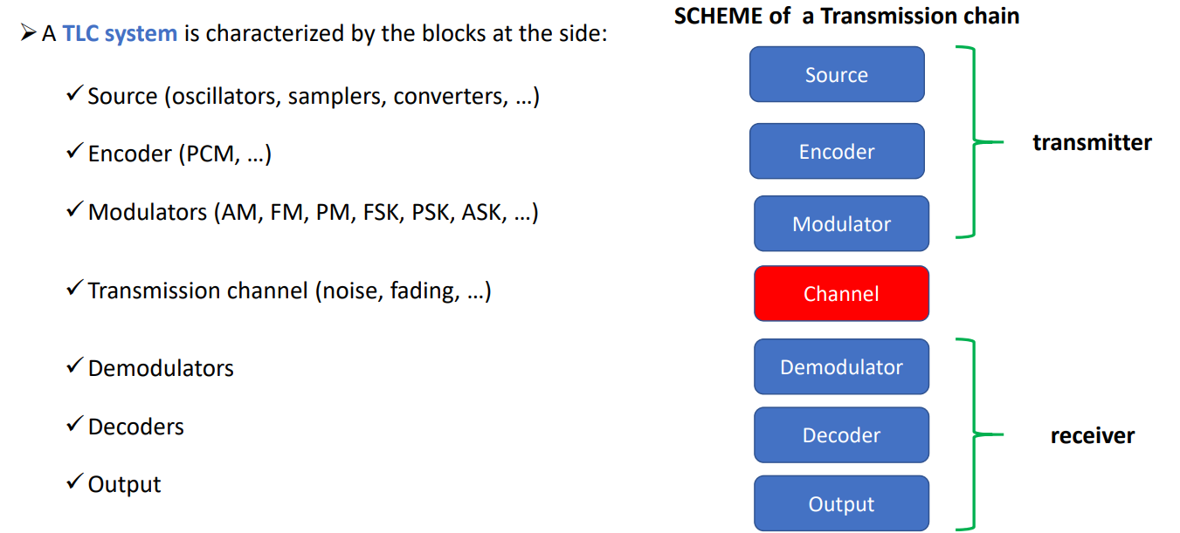

- Source: generate the signal. Examples include oscillators (sine/cosine waves used to transmit signal), samples (choose signals at some points), converters (transform signal into electromagnetic waves), …
- Encoder: use some rules to encode the signal in the correct way. The encoder decides the way in which we have to transform the signal.
- Modulator: it changes the signal to be transmitted by choosing a more suitable signal according to appropriate criteria (bandwidth, errors, interference of channels, …). They can be of various types like AM (Amplitude Modulation), FM, FSK, PSK. Require a demodulator to exist. A signal can be changed in amplitude, frequency or phase.
- Transmission channel: deal with the distortion and noise of the signal.
- Demodulators. Require a modulator to exist. It recognises the transmitted signal and reproduces the original one for the end user.
- Output: the retrieved signal is outputted (like speakers or a screen).

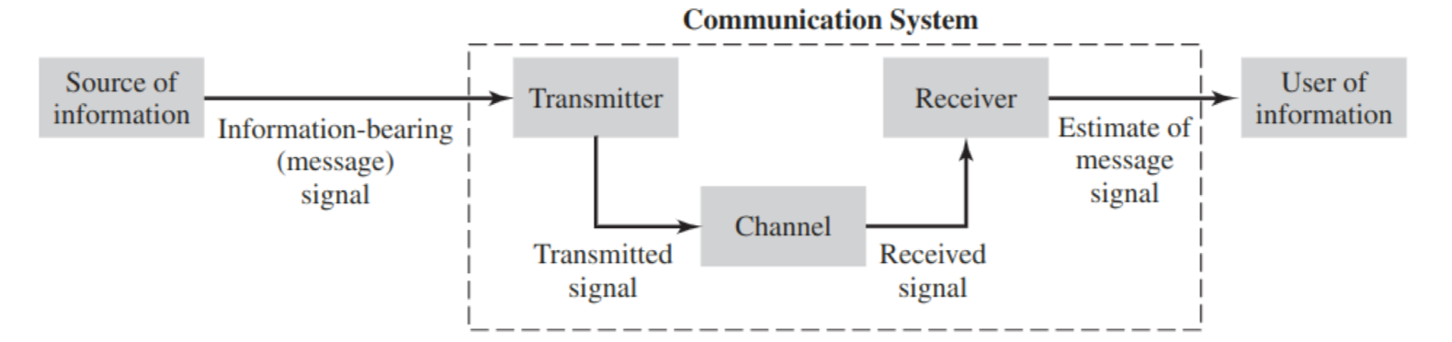
- Transmitter: convert the message signal produced by the source of information into a form suitable for transmission over the channel.
- Channel: transport the message signal and deliver it to the receiver at some other location in space.
The signal is distorted due to channel imperfections 🙁 and noise and interfering signals are added to the channel output 🙁 ⟹ received signal is a corrupted version of the transmitted signal 🙁
- Receiver: produce an estimate of the original message signal for the user.

- Signal: function/distribution of an independent variable (usually time)
- A signal is always real
- We can use complex numbers for mathematical manipulation
- T: period of the signal
- f=1/T: frequency of the signal
- Complex signals are made of compositions of simpler ones

There are different ways in which a signal can be transmitted:
- As it is: (AM, FM radio)
- Sampled: once in a while (telephone) (a sampled signal is less robust to noise)
- Quantized: not all possible values, 8 bits per word (it cause a distortion of the signal)
- Encoded: with protection and error correction codes
- Encrypted: for secure transmission (credit card data, …)

Signal classification (time)
- Time continuous: (noise, car speed, …) ⟹ s(t) defined for each instant of time
- Time discrete: (morse transmission, temperature detected by a sensor) ⟹ in the points not considered the signal does not exists ⟹ s(t) defined just only for some instant of time

Signal classification (periodic vs aperiodic)
- Periodic: if there is a value for which the signal repeats (after a period of time T₀ I have same signal as before)
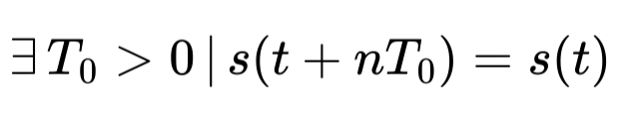
  - T₀ ⇐ period
  - f₀ = 1/T₀ ⇐ fundamental frequency
  - λ₀ = cT₀ = c/f₀ ⇐ fundamental wavelength
  - A periodic signal is defined by its period (in seconds) or the fundamental frequency (in hertz, the inverse of the period)
  - Usually a periodic signal has different frequencies, the first one is called fundamental (f₀ = 1/T₀)
- Aperiodic: signal that is non periodic
- We can decompose a signal in its periodic and aperiodic parts to get informations about changing behaviors that are not regular

Signal classification (deterministic vs random)
- Deterministic: signal which is completely known ⟹ can be predicted
- Random: we known only the probability that the signal takes a certain value

Signal classification (“of power” vs “of energy”)
- Of power: if there exists finite the integral
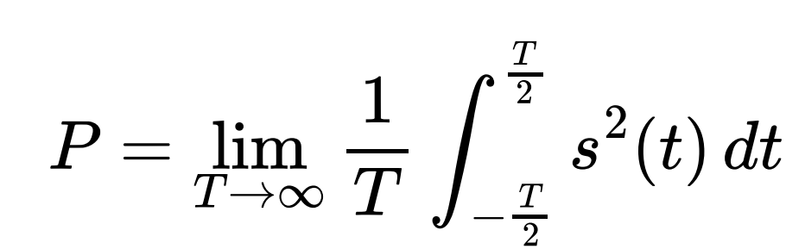
E = ∞ and P < ∞
Periodic signals are always power signals

- Of energy: (ex: rect signal) if exists finite the integral:
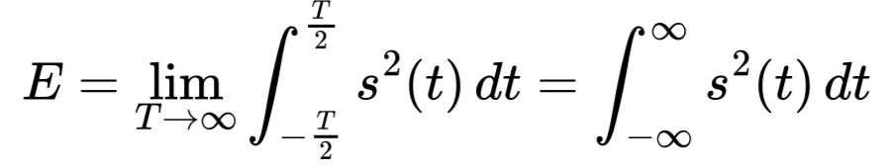
E < ∞ and P = 0

- An energy signal can not be of power (and vice versa)
- All periodic signals are power signals (but not all non–periodic signals are energy signals).

Fourier series - Periodic Signals

Fourier series - Complex coefficients form
- For periodic signal (aka signals of power [ E = ∞ and P < ∞ ])
- Write signal in series form:

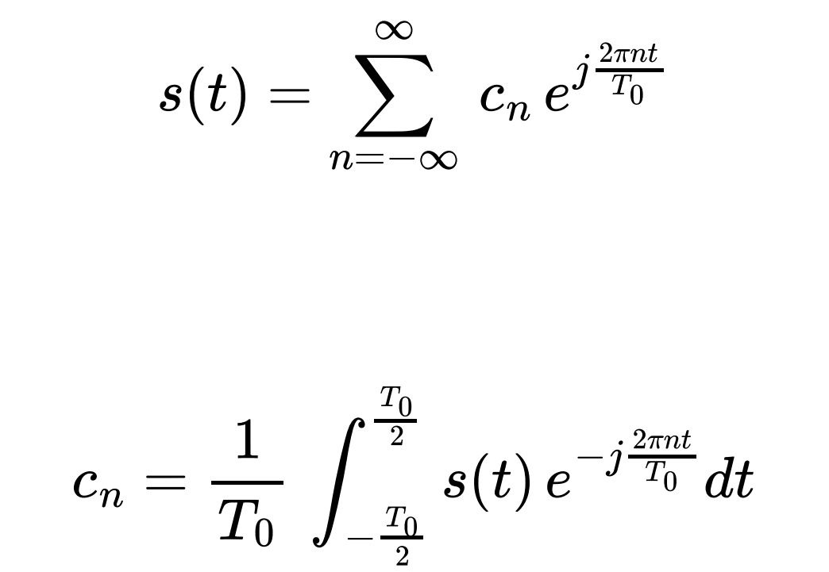

- c_{n} are the coefficients of the signal, are complex numbers (but the signal is real)
- Periodic signal → combination of discrete set of complex functions of frequency
- c₀ (0-th coefficient) ⟹ average value of the signal $\underline{s}$
- With fourier series we can move from time domain s(t) to complex coefficients (and vice versa)

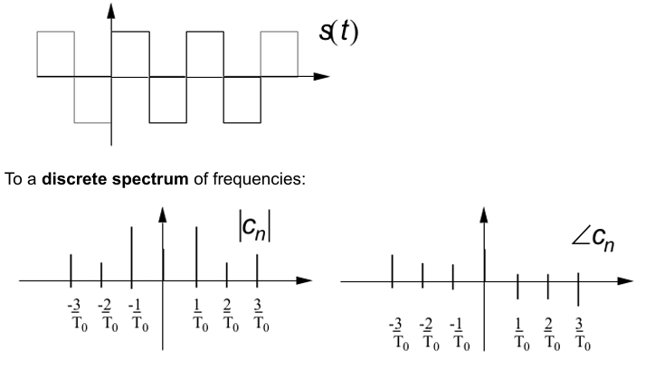


- Bilateral spectrum → coefficients for positive and negative frequencies
- Band: greatest positive frequency with a non-zero coefficient ⟹ is the range of frequencies over which a signal operates
- Frequencies can be common to different signals but their contribution to the overall signal changes (their respective weights changes)
- A periodic signal can be obtained by the superposition of complex exponentials ⟹ if we don’t know s(t) but we know c_{n} we can reconstruct s(t)
- Not all frequencies are needed for periodic signals (only the multiples of the fundamental frequency f₀= 1/T₀ [2/T₀, -1/T₀, …] which are called harmonics) ⟹ the representation on the frequency domain of a periodic signal is discrete

- If s(t) is even [ s(t) = s(-t) ] ⟹ coefficients c_{n} are real
- If s(t) is odd [ s(-t) = -s(t) ] ⟹ coefficients c_{n} are imaginary

TRAIN of rectangular pulses (and triangular pulses)
- Train of rect: sum of infinite rect signals shifted in time
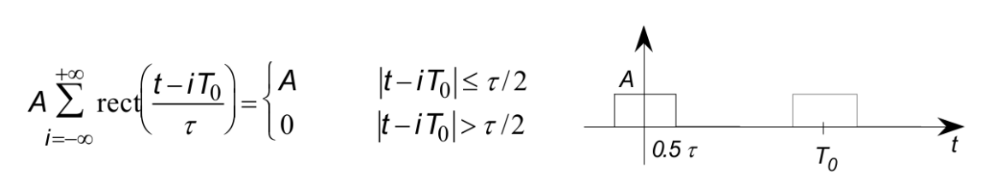
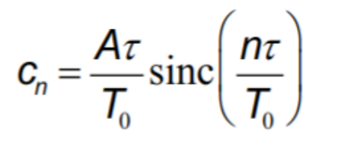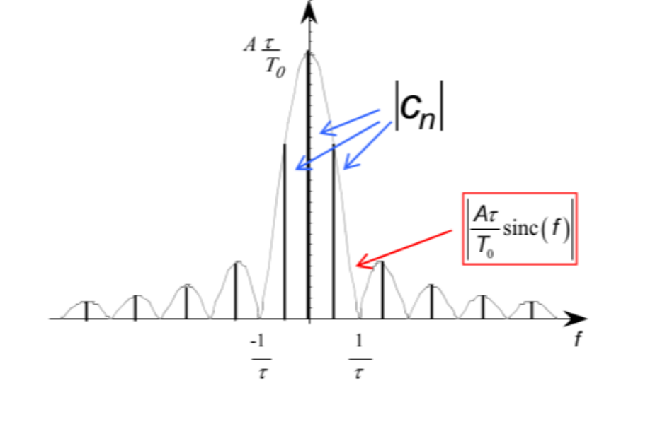
- Coefficients are real (signal function is even)
- Coefficients are decreasing with n (Fourier series must converge) ⟹ sinc function goes to 0 as n→∞

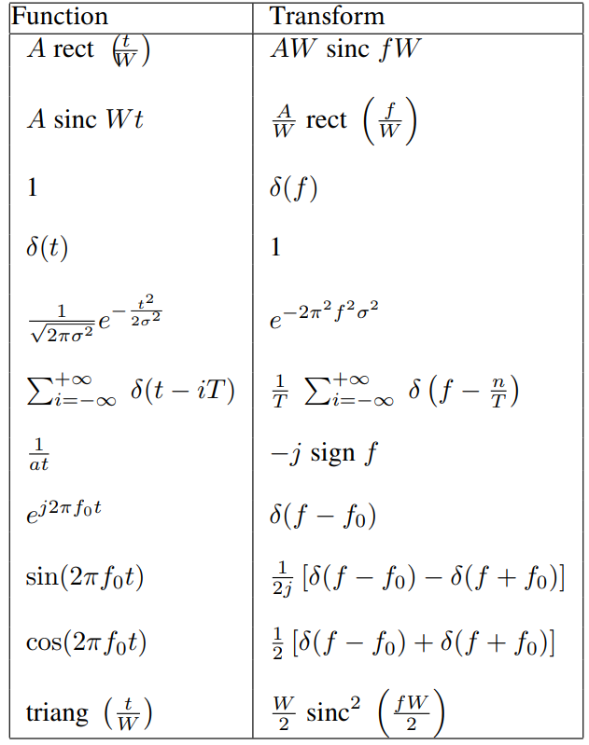

(W is 𝜏 that is the duration of the signal [base])

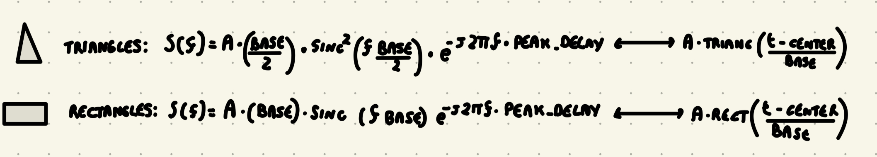

Time frequency relationship
- The shorter the signal is (smaller 𝜏 [or W aka the base/duration]) ⟹ higher contribution of high-frequencies to its spectrum
- In the images T₀ (period) is the same (10sec) ⇔ same f₀ frequency
- (Shorter in time ⟹ faster in frequencies)
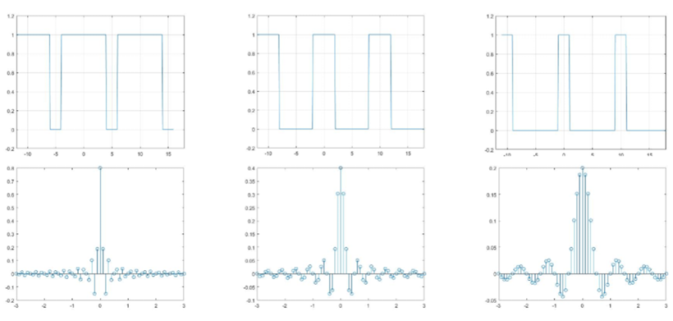
[top imagines: time domain, bottom images frequency domain]

- Shorter rect signals (aka small 𝜏) ⟹ signal is faster ⟹ more c_{n} are important ⟹ contributions of other frequencies get higher

Fourier series - Sine/Cosine Form
Euler’s formulas:
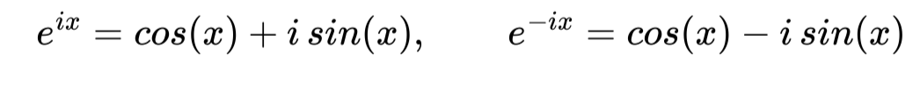

We can describe Fourier series in a different way:
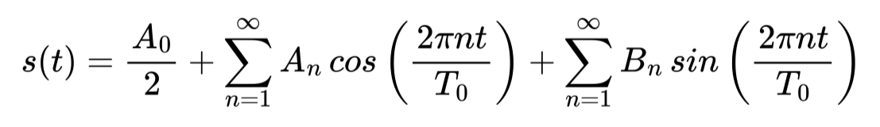
where
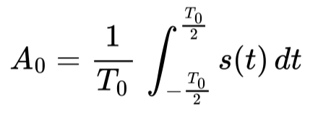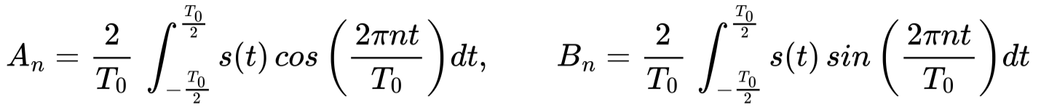

This notation is very useful:
- the coefficients (A₀, A_{n}, B_{n}) are real
- sine and cosine have only positive frequencies as arguments → monolateral spectrum
- There is no B₀ term since the average value of an odd function over one period is always zero.

Also:
that is,
- the cosine function is even, it represents the “even part” of the signal
- the sine function is odd, it represents the “odd part” of the signal
Since they have these symmetry properties, it is not necessary to consider the negative frequencies.

Fourier series - Cosine only Form
- Rather than using sine and cosines we can only use the cosine and put the phase for the sine part (since cosine and sine are related by a shift of 90’)
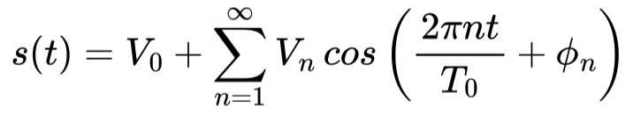
where
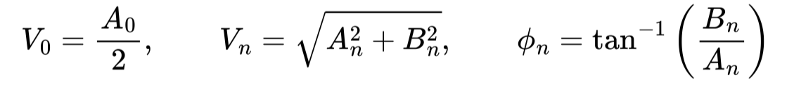
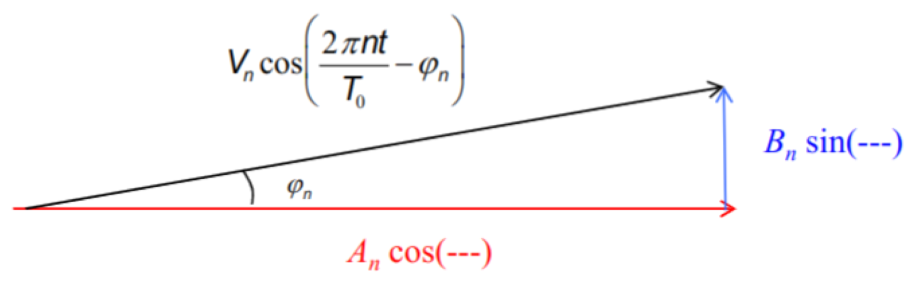

Fourier series - Dirac Delta Form
- Series of rectangular pulses with smaller and smaller pulses (smaller 𝜏)

Dirac delta function (aka unit impulse) it is an even function of time
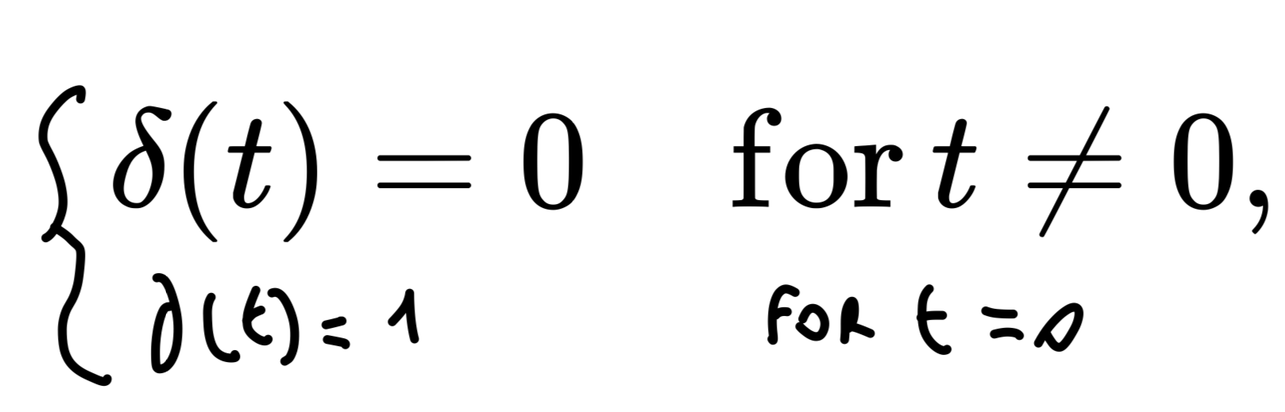
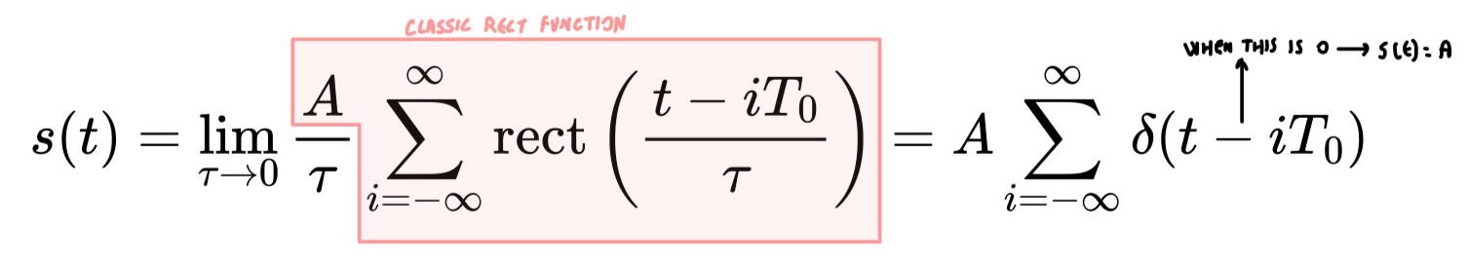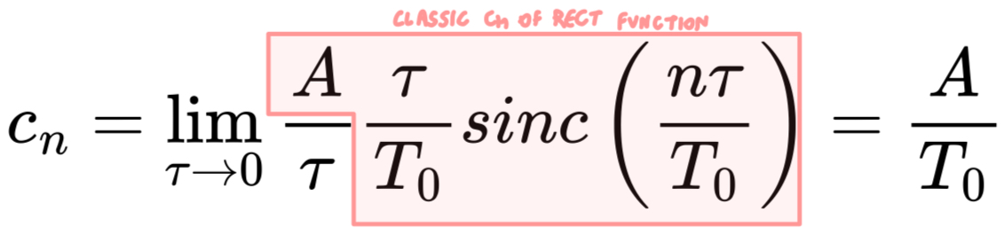
- The coefficient c_{n} of a unit pulse train are equal for all frequencies ⇐ regardless of the n-value c_{n} is always equal to A/T₀
- The derivative of a rect signal is a periodic Dirac delta (impulse) signal with amplitude equal to the amplitude of the rect

- The dirac delta function can be seen as the limit of a series of rectangular pulses of height A/𝜏 and width 𝜏 as 𝜏 approaches zero
- The coefficients c_{n} of a dirac delta function have all height A/T₀ and are located at multiples of the fundamental frequency (0, f₀, 2f₀, -2f₀, … or 0, 1/T₀, 2/T₀, -2/T₀)
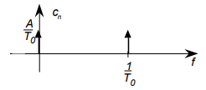

Properties of Diract δ function
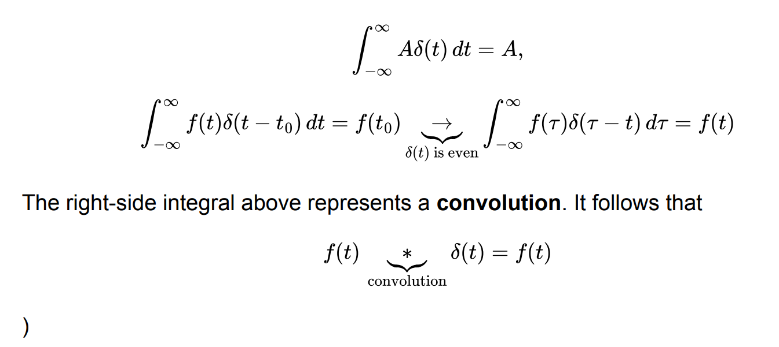
The right-side integral above represent a convolution, it follows that:


Properties of Fourier Series
Fourier series has the following properties:
- Fourier Series of a constant: the fourier series of a constant signal is only the 0 frequency component, i.e. the average of the signal (since the signal does not change), which is equal to the amplitude of the function itself: 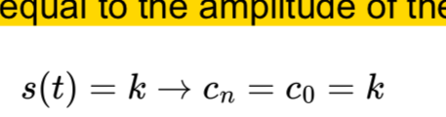
  - ⟹ for any constant function s(t) its fourier series is simply c₀=k and all the other coefficients c_{n}=0 for n≠0

- Linearity: the fourier series coefficients of the linear combination of two periodic signals are equal to the linear combination of the coefficients of the original signals: 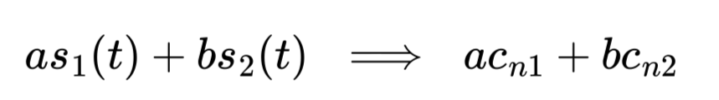
  - ⟹ if s₁(t) and s₂(t) are two periodic signals multiplied respectively by a and b and summed up together, then the fourier series coefficients of the new signal are ac_{n1} + bc_{n2}

- Delay/Anticipation (time shifting): the coefficients of a time-shifted signal are equal to the coefficients of the original signal multiplied by a complex exponential (they are phase shifted):
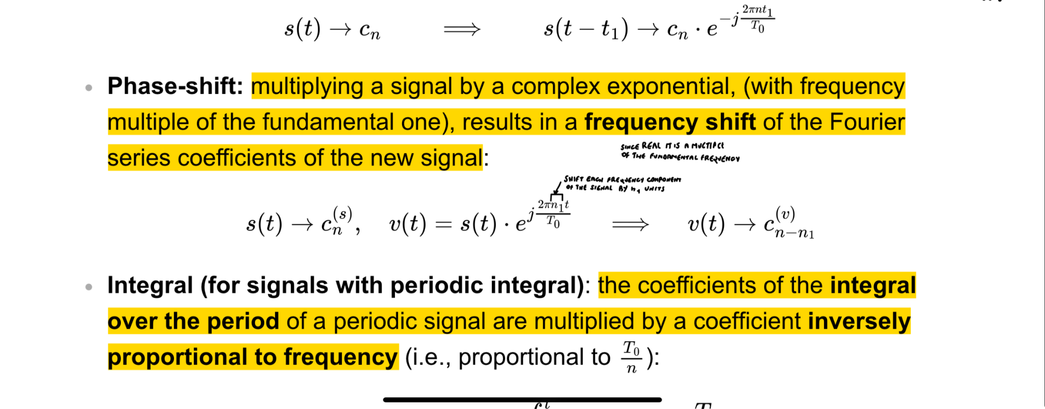
- ⟹ delaying a periodic signal by t₁ results in each coefficient being multiplied by exp(-i2πnt₁/T₀) thus introducing a phase shift without changing the magnitude
- Phase-shift (frequency shift): multiplying a signal by a complex exponential, (with frequency multiple of the fundamental one), results in a frequency shift of the Fourier series coefficients of the new signal:
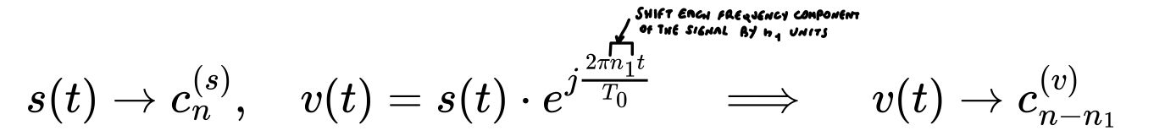
- ⟹ Multiply a periodic signal by exp(j2πn₁t/T₀) shifts its fourier series coefficients by n₁, thus corresponding to a shift in the frequency components of the signal

- Integral (for signals with periodic integral): the coefficients of the integral over the period of a periodic signal are multiplied by a coefficient inversely proportional to frequency:
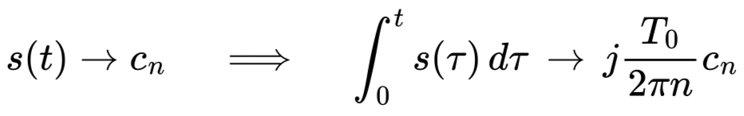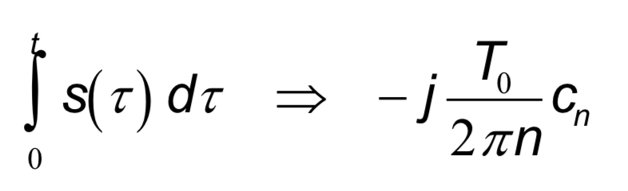
- ⟹ when you integrate a periodic signal over its period you transform each coefficient by scaling it by a factor of -jT₀/2πn

- Derivative (for all signals): the coefficients of the derivative over the period of a periodic signal are multiplied by a coefficient directly proportional to frequency (inverse of what happens with integration):
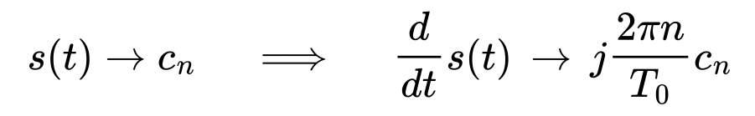
- ⟹ When you differentiate a periodic signal the coefficient are scaled by a factor of j2πn/T₀

Extract coefficient from difficult signals
If you have a complicated signal to reconstruct coefficients:
- Decompose the signal into simpler signals, for which you know the expression
- Associate to each of these sub-signals its own coefficients
- Get the coefficients for the whole signal by summing the simpler coefficients

Example:
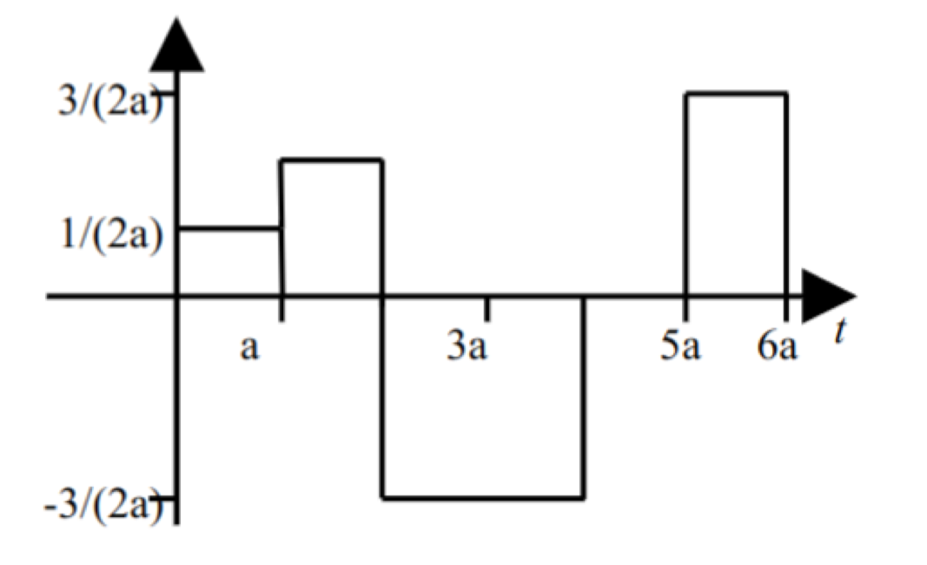
Supposing
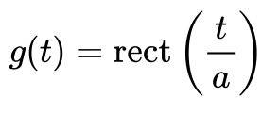
You get that:
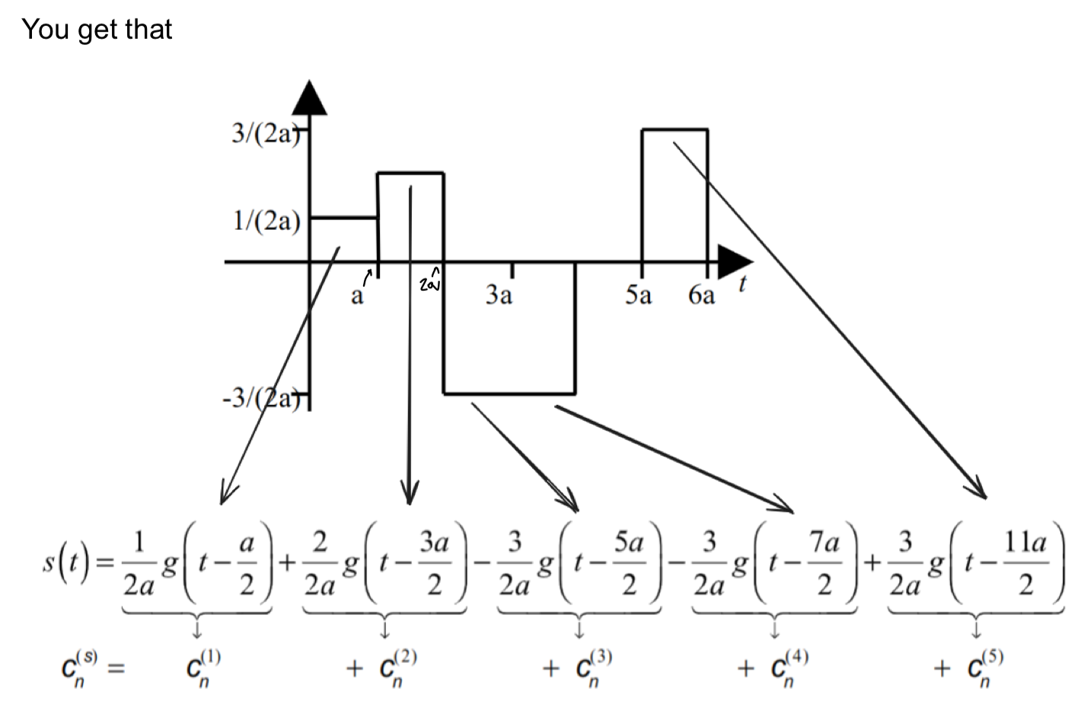
We can see (rect-wave example) that each sub-signal is of the form
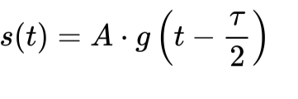
where A is the signal amplitude (height) and 𝜏/2 is half of the signal duration (the time point in the middle of the signal peak).

Transmission of Signal (Response) in a Linear System
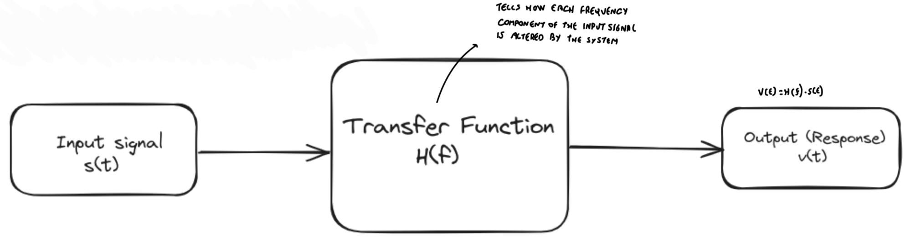
- If you have an input signal s(t) you multiply by the transfer function H(f) to find the output v(t)

Power of a periodic signal - Parseval theorem
- s_{p}(t): simple periodic signal

Obtain power of a signal from the time domain:
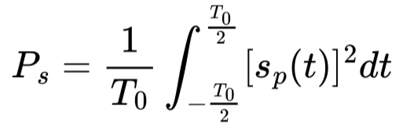

Obtain power of a signal from the its coefficients ⟹ parseval theorem (the total power is the sum of the power of each component)
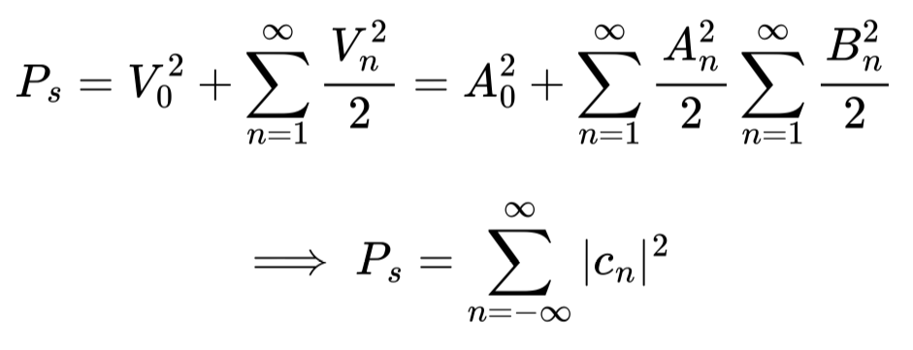

Power spectral density G(f) (aka derivative of power)
- G(f) tells us how the power P is distributed over all frequencies ⟹ tells how each frequency contribute to the total power
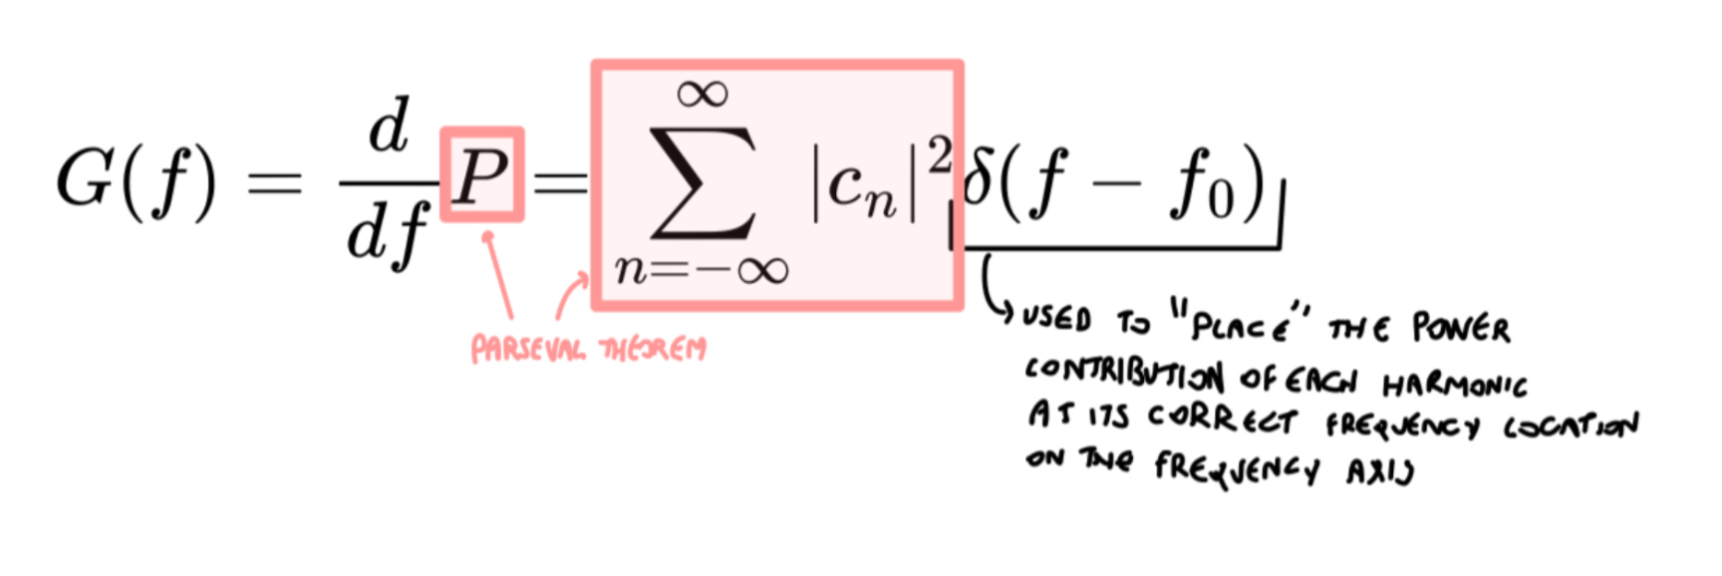
Also we get:
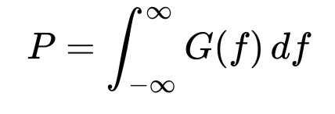

If we assume we are passing through a linear system, the output spectral density will be given by:
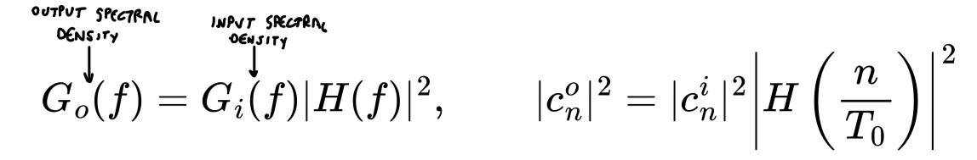

Fourier transform - Aperiodic Signals
- Linear mathematical operation that transforms the time-domain description of a signal into a frequency-domain description without loss of information (the original signal can be recovered exactly from the frequency-domain description).
- Relates the frequency-domain description of a signal to its time-domain description.
- For aperiodic signals instead of n/T₀ we use f

- Fourier transform is for aperiodic signals s(t)
- Fourier transform: from time domain s(t) to frequency domain S(f)
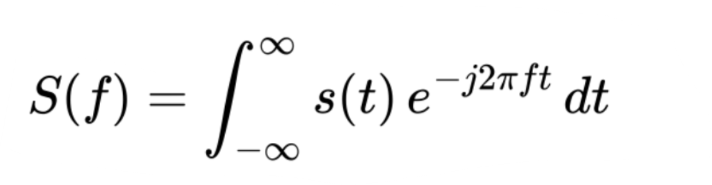
- Fourier antitransform: from frequency domain S(f) to time domain s(t)
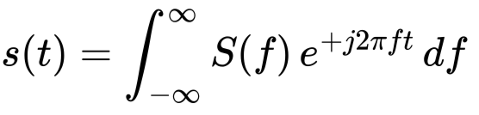
- Fourier pair: antitransform and transform together
- Kernel: exponential term 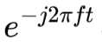

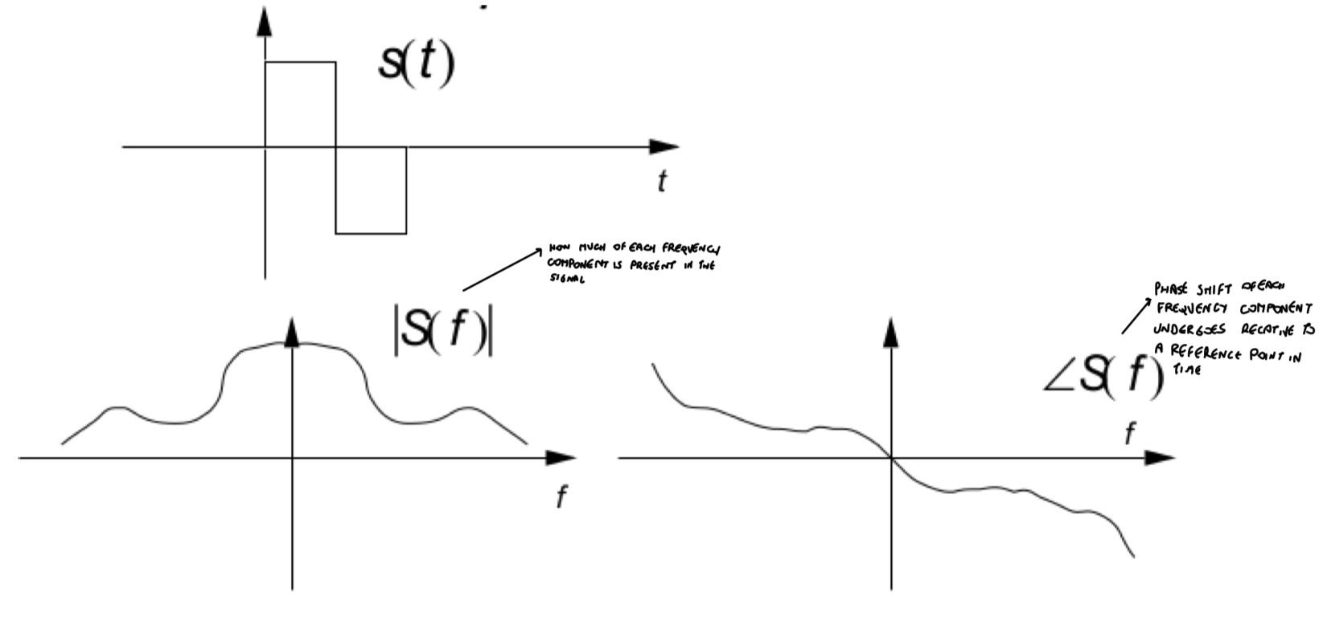
- The frequency spectrum is continuous (for periodic signals it is non-continuous)

Comparison of fourier series with fourier transform
Periodic signal (fourier series):
- Harmonics: positive integer multiples of fundamental frequency (nf₀ or n/T₀)

Aperiodic signal (fourier transform):
- No harmonics → all frequencies contribute (frequency domain is continuous)

The coefficients c_{n} of a periodic signal s_{p}(t) are easily obtained from the transform of the aperiodic signal s(t) that corresponds to a single period

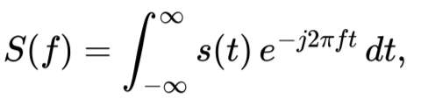
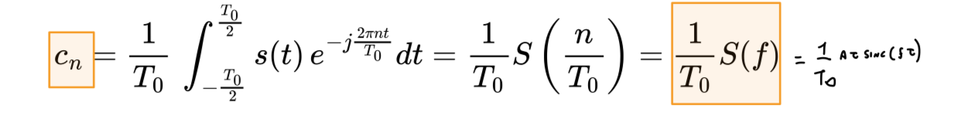

example: a single rect pulse with height A and duration 𝜏 has as fourier transform: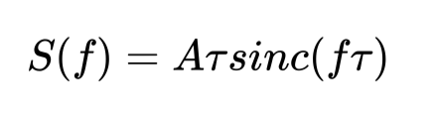the corresponding coefficients c_{n} of the analogous periodic signal series would be given by:
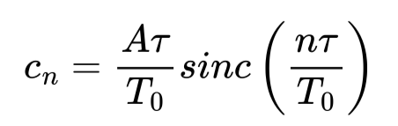 c_{n} = S(f)/T₀ and f=n/T₀
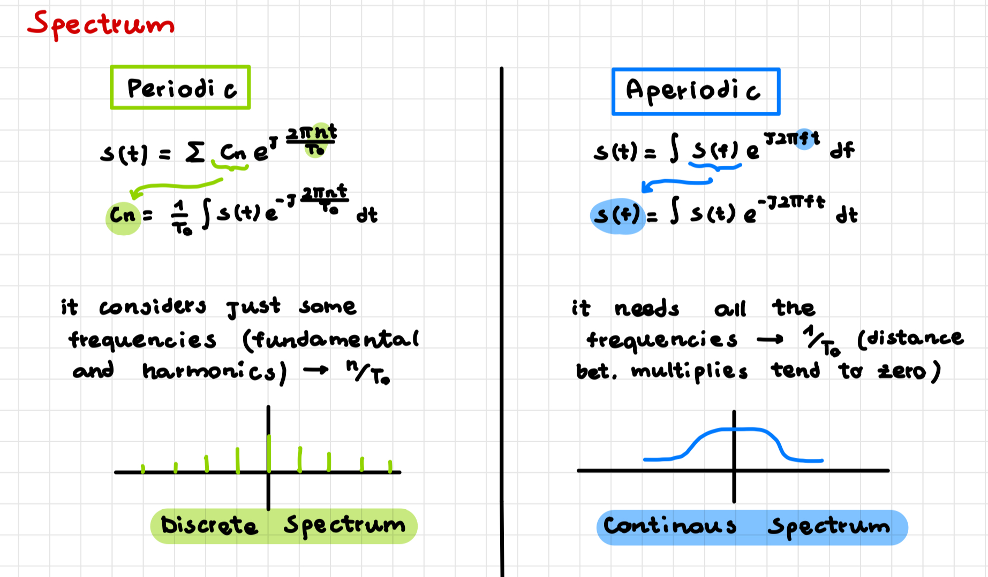

Properties of Fourier transform
- Linearity: the transforms of the linear combination of two aperiodic signals are equal to the linear combination of the transforms of the original signals:
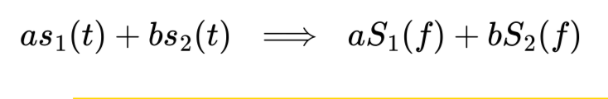
- ⟹ if s₁(t) and s₂(t) are two aperiodic signals multiplied respectively by a and b and summed up together, then the fourier transform of the new signal is aS₁(f)+bS₂(f)

- Delay/anticipation (time shift): the transform of a time-shifted signal is equal to the transform of the original signal multiplied by a complex exponential (it is phase-shifted): [if a signal is delayed in time the spectrum is phase shifted in frequency]

- ⟹ delaying an aperiodic signal by t₁ results in each frequency in the frequency domain being multiplied by exp(-j2πnft₁) thus introducing a phase shift without changing the magnitude

- “Phase-shift” (frequency shift): multiplying a signal by complex exponential, (with frequency multiple of the fundamental one), results in a frequency shift of the Fourier transform of the new signal [if there is a phase shift in time domain than there is a frequency shift in frequency domain]
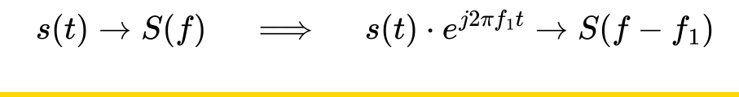
- ⟹ Multiply an aperiodic signal by exp(j2πf₁t) shifts its fourier transform by f₁, thus corresponding to a shift in the frequency components of the signal

- Integral: the transform of the integral over the period of signal are multiplied by a factor of 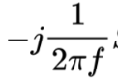 , inversely proportional to frequency:
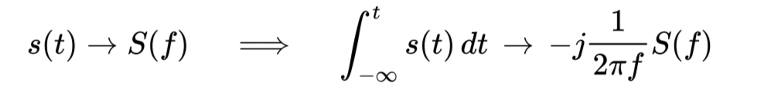
- ⟹ when you integrate an aperiodic signal over you transform each frequency by scaling it by a factor of -j/2πf

- Derivative: the transform of the derivative over time of a signal is multiplied by a complex coefficient directly proportional to frequency (inverse of what happens with integration):
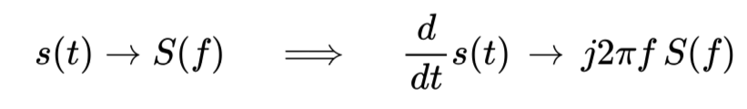
- ⟹ When you differentiate an aperiodic signal the frequencies are scaled by a factor of j2πf

Cosine Multiplication: Multiplexing in Frequency
- Multiply a signal s(t) by a sinusoidal function
- The signal is modulated by two complex exponentials
- When a signal is multiplied by a complex exponential, it results in a frequency shift of S(f)
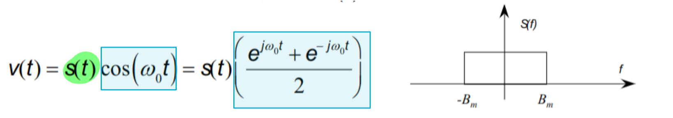
- Apply properties of linearity and we apply phase shift through a multiplication by an exponential
- f₀ = ω₀/2π
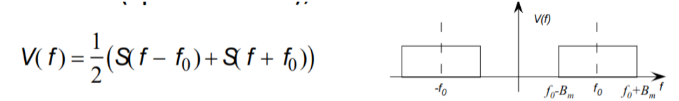

- We get a frequency shift of f₀ ⟹ signal is not centered in 0 but is centered in ± f₀ → Frequency Division Multiple Access (FDMA)
- Cosine multiplication is used to transmit multiple signals simultaneously at different frequencies (FDMA)
- NOTE: when we apply cosine multiplication we get two signals centered in ± f₀ but with height halved ⟹ from A we get A/2

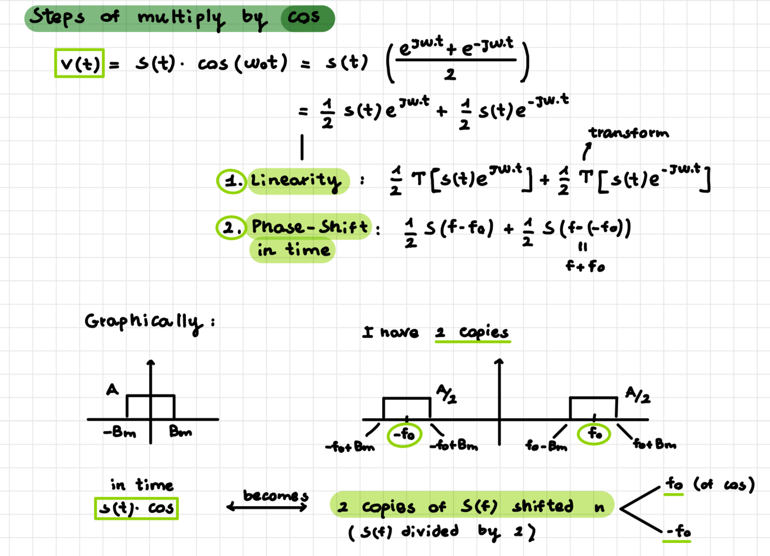
- Multiplexing in frequency done by multiplying each signal by a cosine at different frequency (which generates a frequency shift in the spectrum)
- It occupies some frequencies for all the time

Utility of Many Frequencies
- Frequency Division Multiple Access (FDMA): transmit multiple signals at same time, as a composite signal, using different frequency bands for each signal. Different signal components separated at the receiving end ⇐ cosine multiplication
- Frequency Division Duplex (FDD): when you transmit different signal simultaneously at different frequencies in both directions (forward/backward)
- Frequency Reuse in Cellular Lines: cellular networks can be divided into cells, each of which uses a unique set of frequencies to avoid interference with close cells
- GSM (2G): use pattern of frequency reuse where each frequency is shared among cells but is distant enough to avoid interference
- LTE(4G): soft reuse ⟹ allow more dynamic allocation of frequencies

Convolution
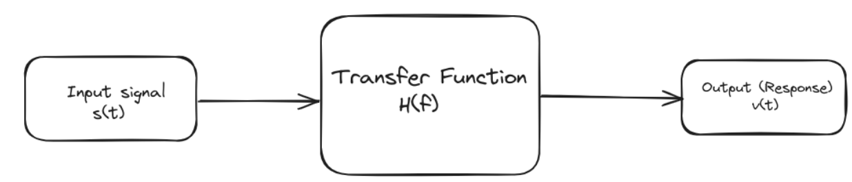
Frequency domain, passing input signal through linear system correspond to multiplying its transform S(f) by block’s transfer function H(f):
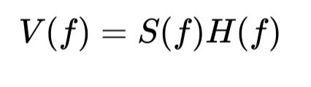
Time domain, correspond to applying convolution between s(t) and antitransform of H(f), h(t) which we call impulse response:
v(t) = s(t) ⋆ h(t)

Convolution Theorem: the fourier transform of a convolution of two functions is equal to the product of their fourier transform
- ⟹ More generally: convolution in one domain (e.g., time domain) equals pointwise multiplication in the other domain (e.g., frequency domain) and vice versa.

- If the input signal s(t) is Dirac we get v(t) = h(t) ⇐ the convolution between a function and Diract’s delta is the function itself
- h(t) is called impulse response (it represent the response to an impulse input signal δ(t) passed through a linear system)
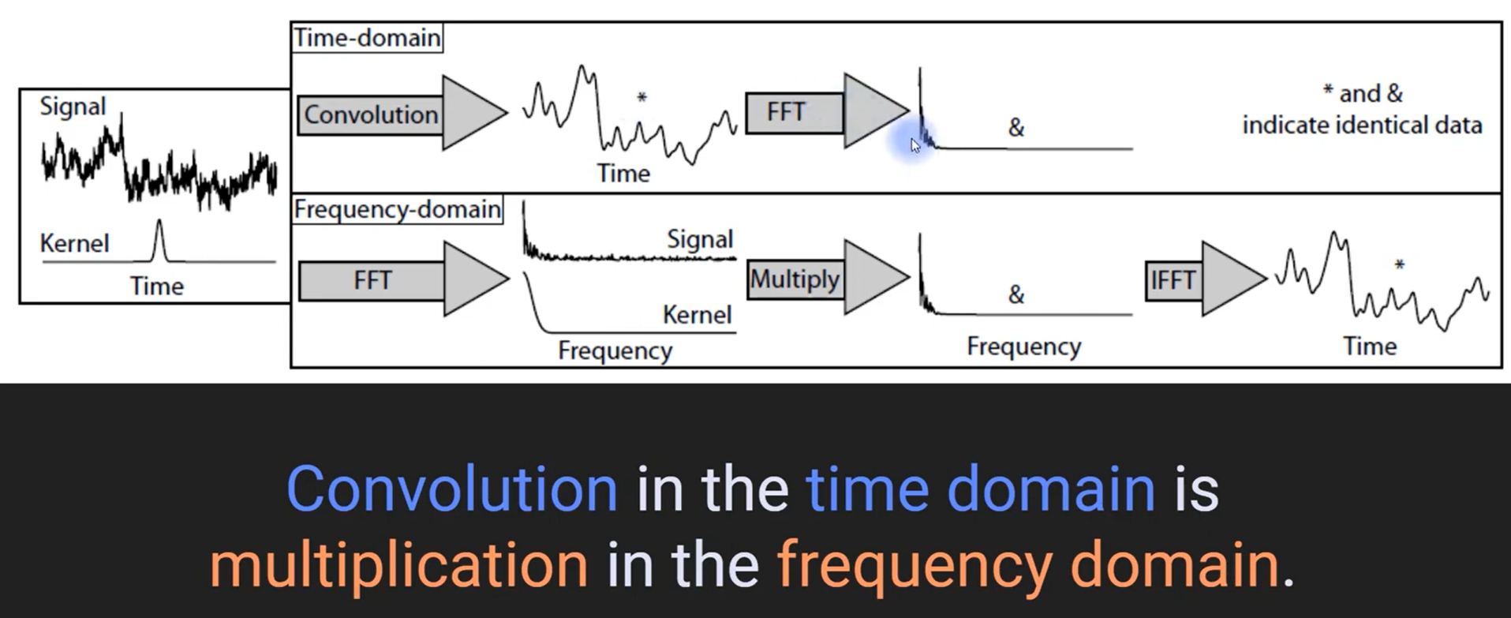
Convolution in the time domain is the same as multiplication in the frequency domain

Energy E - (Parseval Theorem) - Spectral Energy Density
Energy in time domain:
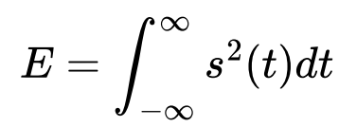

Energy in frequency domain:
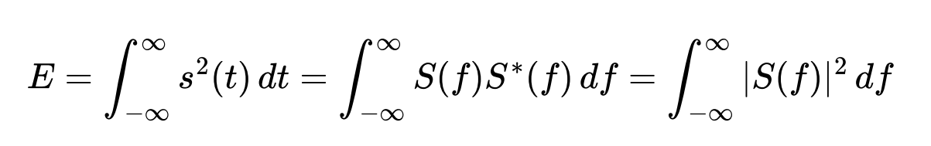
Spectral energy density 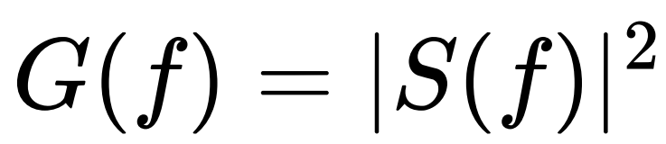

and so:
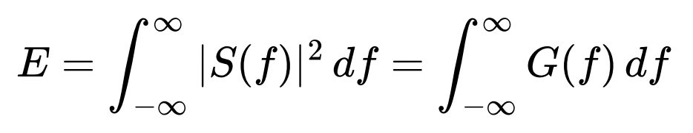

If we consider only interval between two frequencies ⟹ energy of a signal between those frequencies can be calculated as:
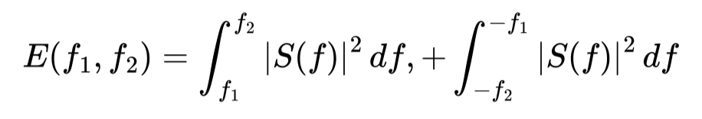

Energy through a Linear Block
- Frequency Domain: input pass through a linear system (block) ⟹ simple product
Y(f) = H(f)S(f)
- Time Domain: input pass through a linear system (block) ⟹ convolution operation
y(t) = s(t) ⋆ h(t)

Spectral density of energy at the output G_{o}(f) is related to the spectral density at the input G(f):

Block
- Delay block ⟹ does not change energy, it operates only on the phase
- No distort ⟹ does not change the shape, it change the energy (amplifier)

- Delay block: linear block that don’t change the energy (change the phase)
- Amplifier: linear block that change the energy but does not change the shape

Filters
Filter defined as any linear system.
- Low-Pass Filter (LP) - cuts frequency above a certain threshold, only low frequencies can pass
- High-Pass Filter (HP) - cuts frequency below a certain threshold, only high frequencies can pass
- Band-Pass Filter (BP) - only certain frequencies can pass
- Band-Stop (notch-filter) (BS) - all frequencies pass except some frequencies

Can not have a rectangular ideal filter ⟹ the output to a δ(t) impulse response would be shaped in such a way that the output signal would start at a time before the input impulse (it is not causal, output arrives before the input 🙁)
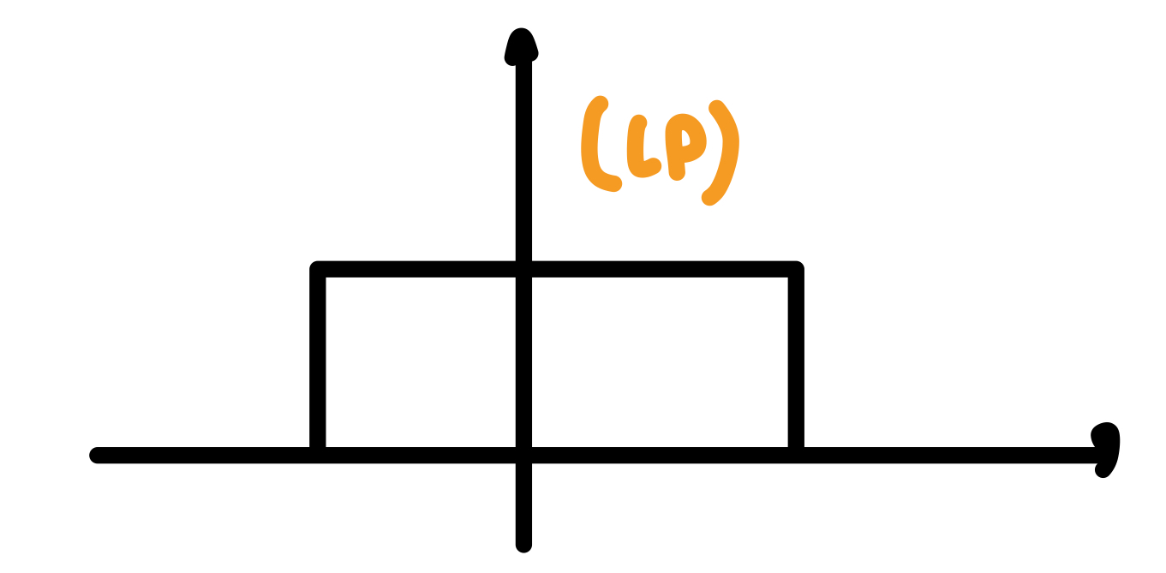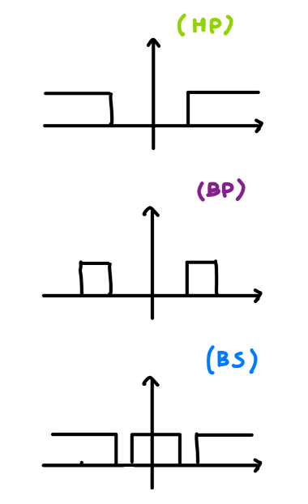

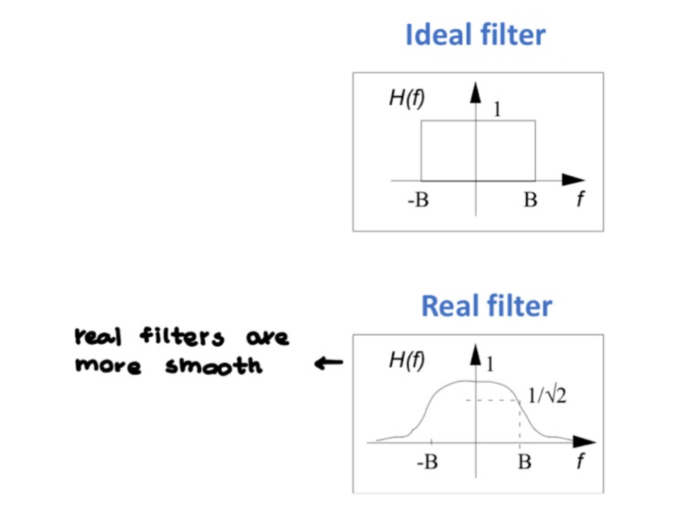

Correlation
- Measure similarity between two signals
- (It is similar to convolution)
- Since a linear block (filter or other) causes shape changes and/or delay of the input signal ⟹ need a system to
  - Understand what is the delay of the signal
  - Decide which of the signals that were transmitted arrived

For aperiodic signals, defined as:
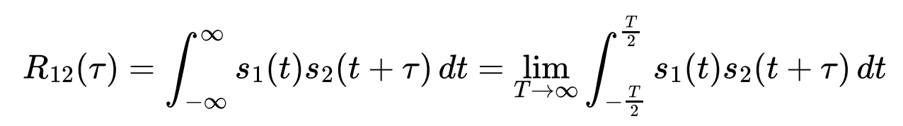
For periodic signals, add a division by period T₀:
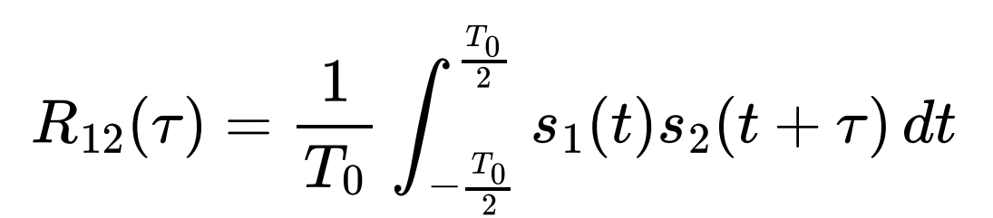

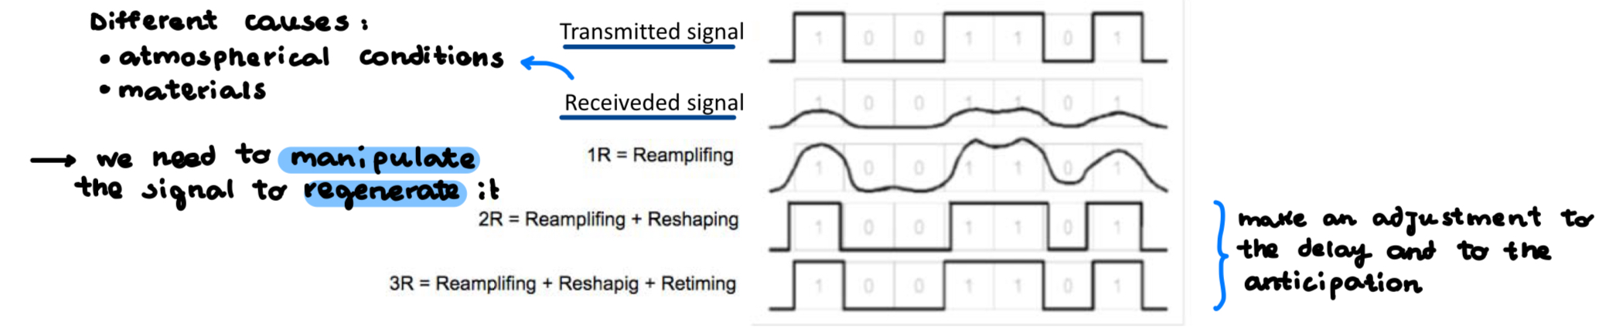

Correlation for delay calculation
If I transmit a signal s(t) and the signal arrives after a delay α, I can use correlation to calculate this delay.

Correlated with its delayed version shifted by 𝜏. The idea is that the correlation value will be maximum when 𝜏=α, because then you are comparing the signal with its exact self (with no deplays).

For different delays (𝜏) that I can try, there is only one delay that overlap perfectly (α=𝜏) and it represent maximum correlation

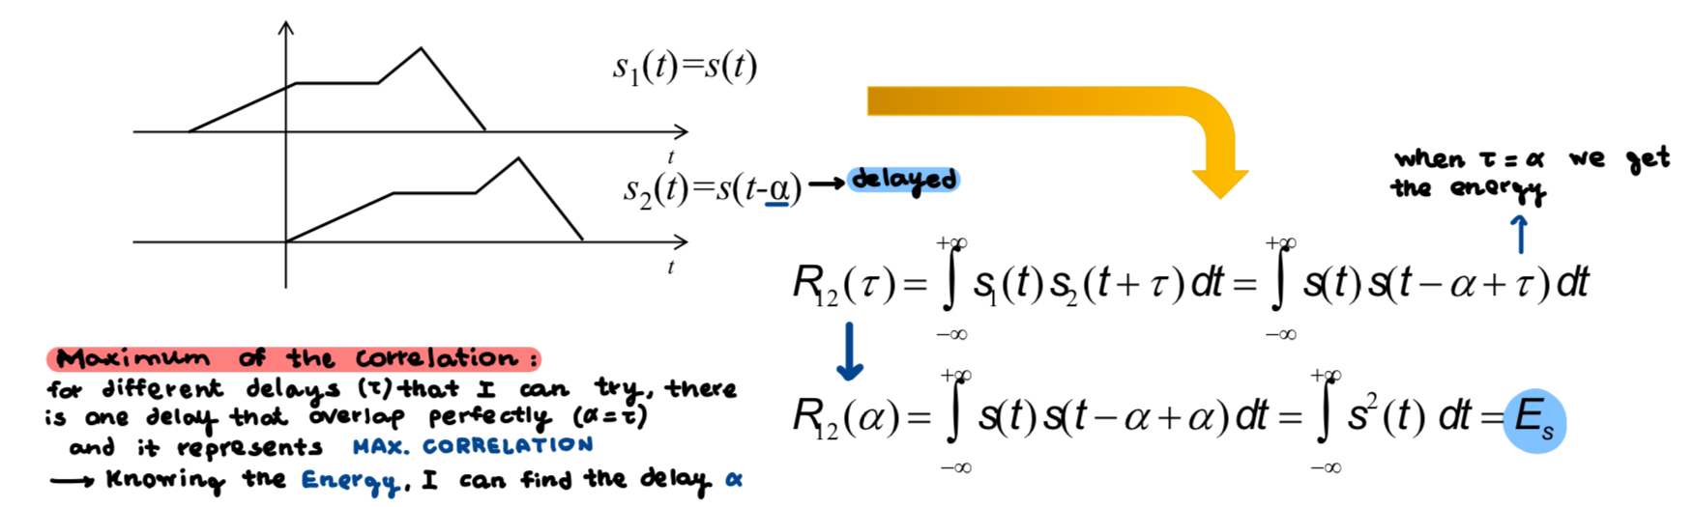

Correlation and Power (Energy) - energy/power of the sum of two signals
Calculate the energy of the sum of two signals:
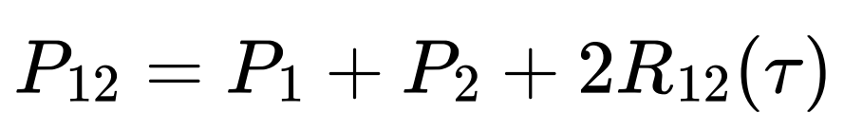
- If signal 1 and signal 2 are uncorrelated ⟹ R₁₂ = 0 ⟹ the energy of their sum is the sum of their energies
- If signal 1 and signal 2 are correlated ⟹ we need to compute also 2R₁₂ (calculated on a specific amount of 𝜏)

Autocorrelation
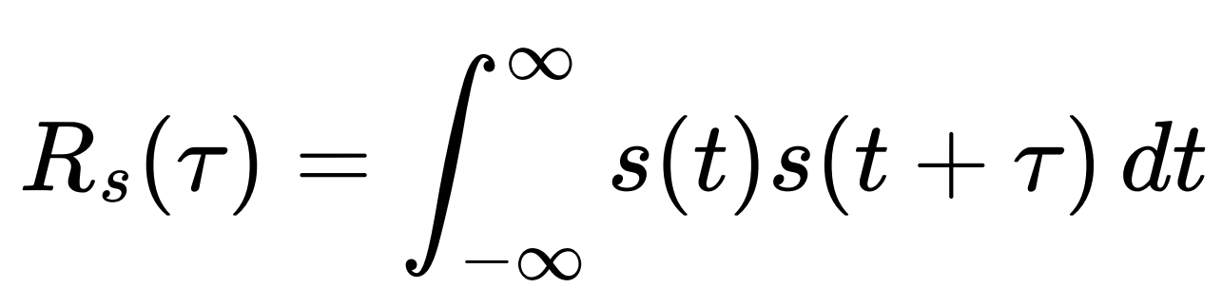

Autocorrelation: correlation of a signal with itself shifted ⟹ integral of the product between a signal and itself shifted

Autocorrelation in time and energy spectral density G(f) are a fourier pair.
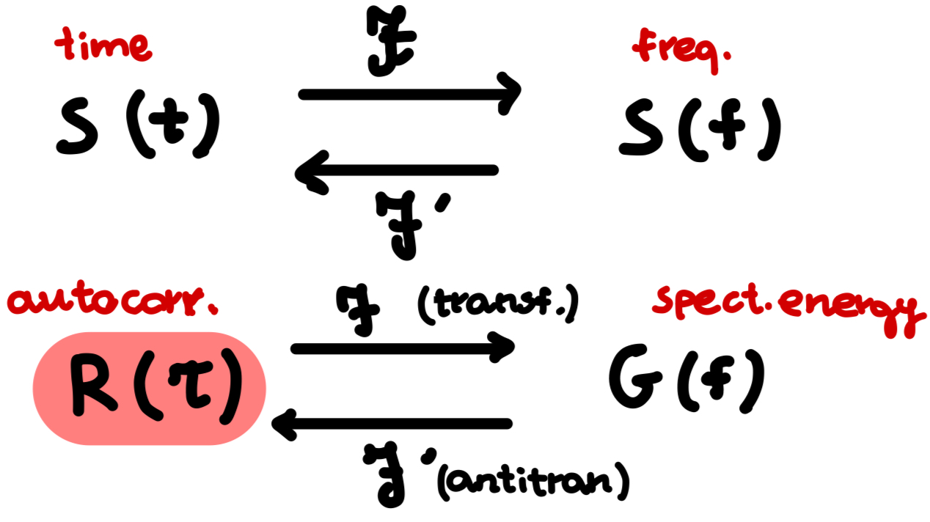

Properties of autocorrelation
- R_{s}(𝜏) with 𝜏 = 0 ⟹ maximum autocorrelation ⟹ R_{s}(0) ≥ |R_{s}(𝜏)|
- Maximum autocorrelation is equal to the energy ⟹ R_{s}(0) = E_{s}
- Autocorrelation is even symmetric function ⟹ R_{s}(-𝜏) = R_{s}(𝜏)
In the case of a power signal, similar conditions apply, but with power instead of energy

Autocorrelation of a Periodic Signal
For periodic signal, autocorrelation and power spectral density are a fourier pair ⟹ to get power spectral density you apply fourier transform to autocorrelation

Product in the frequency domain corresponds to the convolution in the time domain
V(f) = S(f)H(f)
v(t) = s(t) ⋆ h(t)

⬇️_____________________________⬇️

Random signals
- Random variable: result of a random event, we know a priori only the possible values, but not when each of them may occur
- If we have a random variable as input to a block, the transformations are applied to the distribution of the random variable

Example: if we have a gaussian noise as input to an amplifier for 3
- Input: gaussian with mean 0 and str. deviation around +1 and -1
- Output: gaussian with mean 0 and str. deviation around +3 and -3

Random Process
- Random process: relationship that links the random outcome of an experiment to a function in time ⟹ it models how the outcomes of some random experiments evolve over time
Time continuous random process have the following realization (aka sample function):
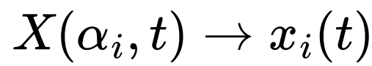

Time discrete random process have the following realization (aka sample function):
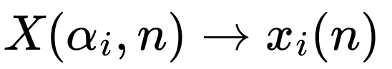
Note:
- For fixed i, the signal x_{i}(t) or x_{i}(n) is deterministic
- At fixed t (or n), X(t) may assume all the values that various (infinite) x_{i}(t) assume in t, and thus X_{t} = X(t) is a random variable
- Family of all these random variables forms random process

Cumulative distribution function for continuous and discrete variables respectively:
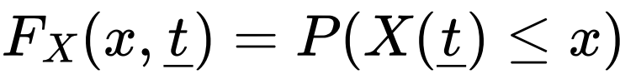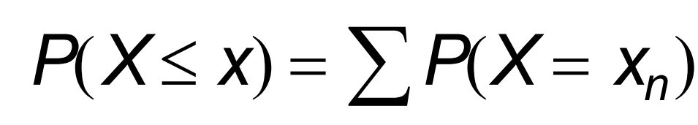

Joint (second order) cumulative distribution function: to known what happens to the process at time t₁ and t₂

Random Process statistical indices
Model the process by considering only some meaningful statistical measures:
Probability density function (PDF):
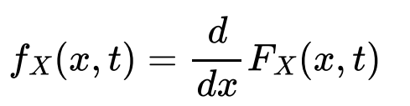

Mean (“most probable value that X can take”):
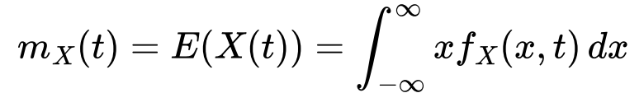

Power (mean of squared signal):
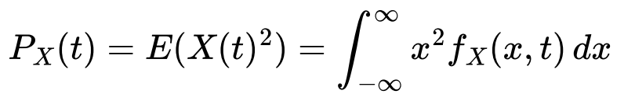
Variance (how “distant” the values are):
It is useful to define second-order indices to allow the description of relationship between different random variables corresponding to different times (autocorrelation)

Autocorrelation (correlation between random variables corresponding to time t₁ and t₂):
Autocovariance (measure independent of mean value):
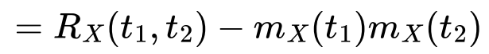

Stationary process - “time invariant”
- Process for which all the statistical functions characterizing it are invariant with respect to time
- If this kind of process is divided into number of time intervals, various sections of process exhibit essentially the same statistical properties
- If all statistical functions characterizing a process are invariant with respect to time ⟹ the process is stationary in strict sense (difficult to verify 🙁) ⟹ consider wide-sense stationarity

Wide-sense (weak) stationarity
- Mean of random process is a constant independent of time
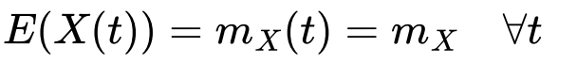
- Autocorrelation of the random process only depends on the time difference:
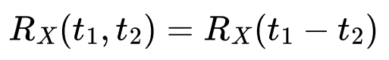
or just like for a deterministic signal:
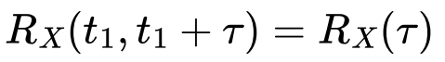

Correlation satisfies the same condition of deterministic signals.

⬆️ _____________________________ ⬆️

Power spectral density G_{x}(f) of stationary signals
- Power density G_{x}(f): for stationary random signals, what is obtained by transforming (in Fourier sense) their autocorrelation R_{x}(t)
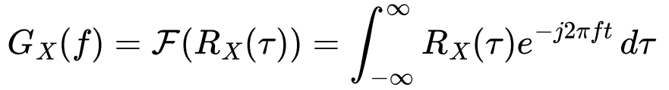
Since R_{x}(t) satisfied all the conditions of an autocorrelation of a deterministic signal, G_{x}(f) satisfies all the conditions of a power spectral density
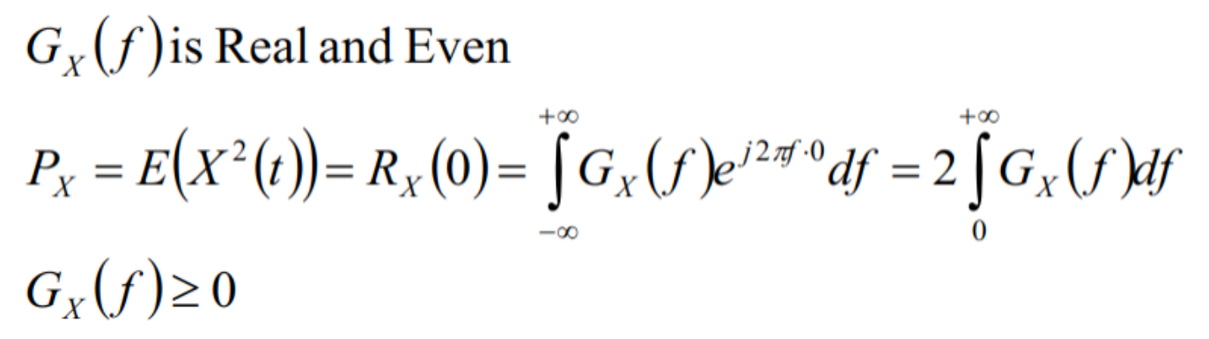

Noise
- Noise sums up to the signal
- Noise is (considering short time frame) a stationary random process
- Constant mean, constant variance and constant power
- Autocorrelation and autocovariance dependent only on the difference between the two instant of time considered
- Central Limit Theorem ⟹ noise at a fixed time n(t) can be modeled by a gaussian random variable

White noise
- Idealized noise process
- Totally uncorrelated with itself → autocorrelation function of white noise is a Dirac pulse in t = 0
- Power spectral density is independent of frequency → all frequency components of noise are present in equal amounts
- White noise has a constant power spectral density
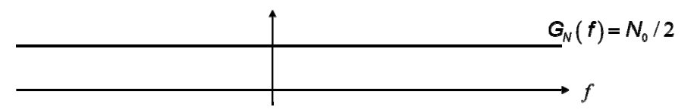

- White noise is also called additive white gaussian noise

- A signal which is a constant in frequency domain (white noise) in time domain will follow a distribution of a gaussian with mean=0 and variance=σ² (but it takes the values from a gaussian, but might not be a gaussian)

Sampling - Sampled Signal S_{c}(t)
- Pulse modulation refers to variation of some parameters of a pulse train in accordance to message signal
- Possible to transmit different signal at the same time by means of time multiplexing, when you sample the signals and interleave them
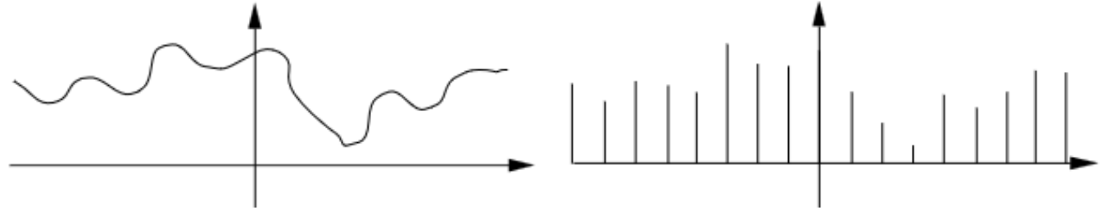

- A finite-band signal can be reconstructed from its sample ⟹ knowing only some values at some time instant (as long as they are sufficiently dense [not separated by too much time])

- Multiplying the signal by a sequence of Dirac pulses (in time domain):
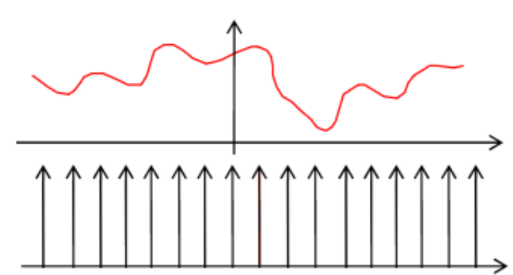

Then sampled signal is described by this formula:
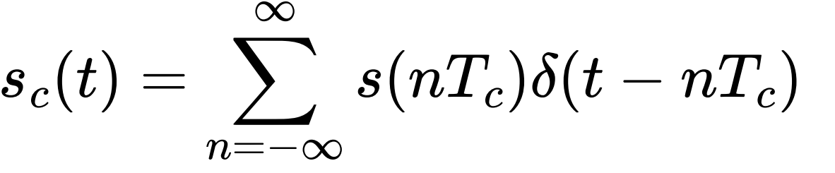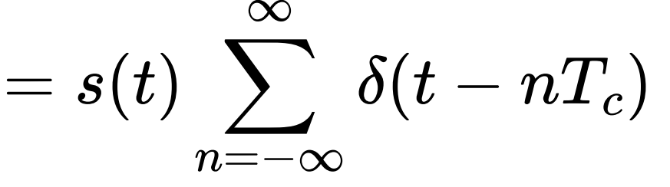
It represents values of a signal at time t multiples of T_{c}, multiplied by a sequence of Dirac pulses, spaced at time multiples of T_{c} [T_{c} is the sampling of the signal]

- When we take the sample we say that at all the other time instant the signal s(t) is 0
- Given only some values of the signal, I can reconstruct the signal in all the time instant (if the sampling is enough dense)
- Regular sampling ⟹ when we take signal evenly spaced in time instant (fixed T_{c})
- To reconstruct the signal s(t), it must be band limited → spectrum must have a limited number of frequencies
- Sampling will be at time 0, T_{c}, 2T_{c}, -T_{c}, -5T_{c}, … that is 0, 1/f_{c}, 2/f_{c}, -3/f_{c}, …

Spectrum of Sampled Signal
- T_{c} ⇔ sampling period or sampling interval
- f_{c} = 1/T_{c} ⇔ sampling frequency or sampling rate

S_{c}(f) is the replica of S(f) in multiple frequencies nf_{c} (we multiply s(t) by a series of dirac δ)

Process of uniformly sampling a continuous time signal of finite energy results in the sum of several spectra that are the copies of S(f) shifted at frequency n/T_{c} (nf_{c}).

Sampling theorem
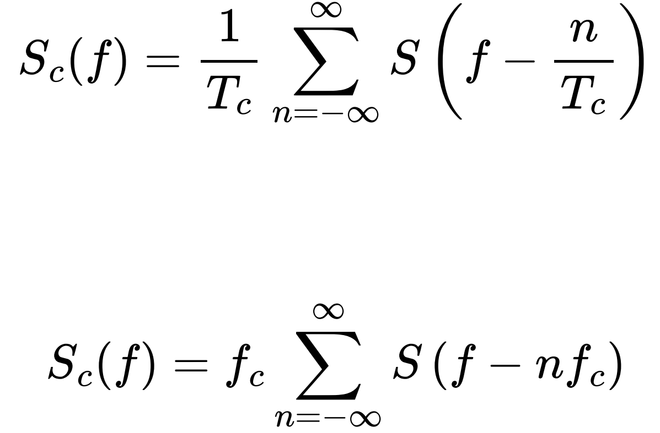
- If T_{c} = 0 ⟹ no separation of the δ and I take the signal at all time points
- If T_{c} → 0 ⟹ 1/T_{c} = f_{c} → +∞ the replica shift towards ∞ ⟹ only the original S(f) remains

NOTE: a series of dirac in the time domain space by T_{c} in the frequency domain becomes a series of dirac spaced by n/T_{c} ⟹ replicas will be at 0, 1/T_{c}, 2/T_{c}, -1/T_{c}, -2/T_{c}, … (Sampling Signals)

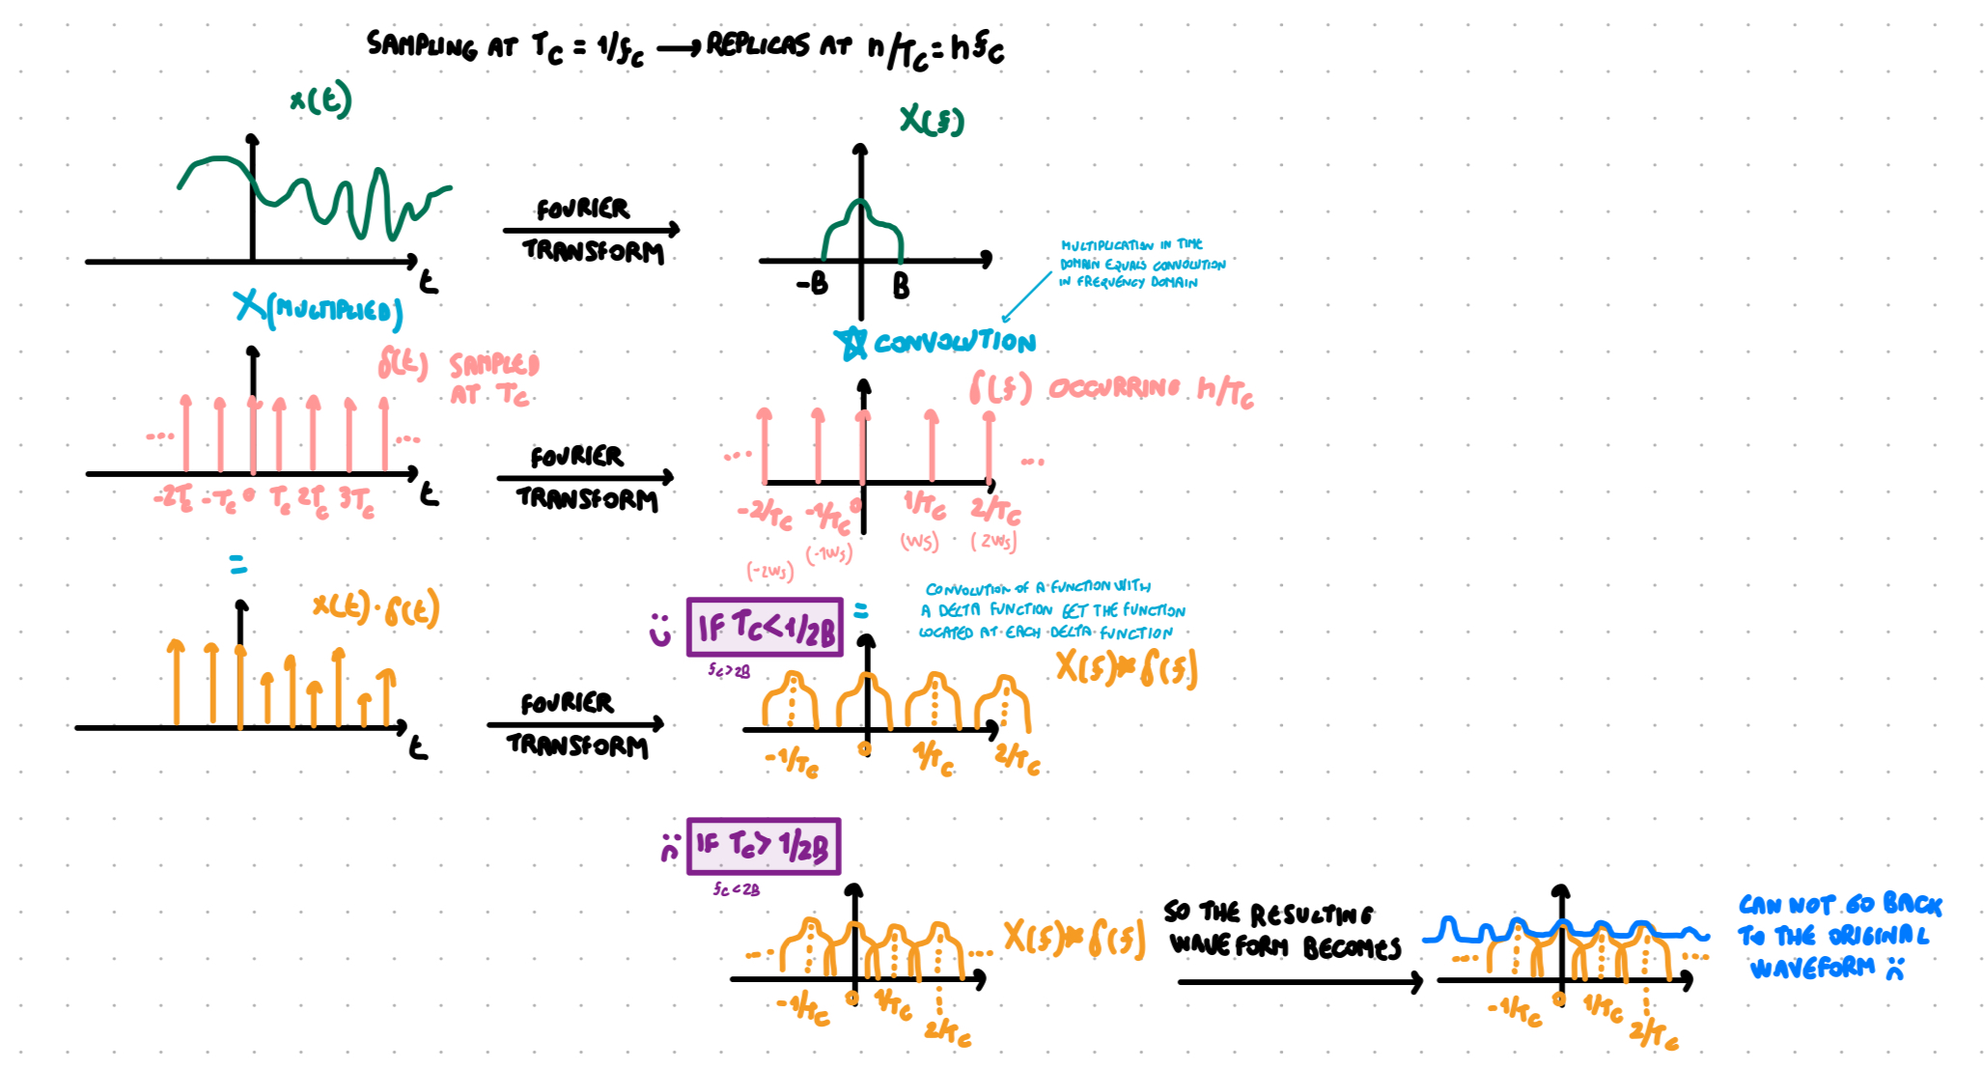

- If I consider all the time instant ⟹ of course I can reconstruct the signal
- If I consider only some time instant ⟹ I can reconstruct the signal only if the spectrum replicas do NOT overlap, so that I can take (aka filter) the original one centered in zero)

NOTE: if s(t) has infinite bandwidth each value of T_{c} makes overlap of the spectrum replicas ⟹ so there is distortion ⟹ that’s why the signal needs to be band limited

Nyquist criterion T_{c} < 1/2B ⇔ f_{c} > 2B
Task: reconstruct the full signal from the sampled one
- If I have all time instant ⟹ I can easily reconstruct the signal
- If I have only some time instant ⟹ I have to make sure that the spectrum replicas in S_{c}(f) do not overlap ⟹ we must determine a criterion for which the signal spectrum replicas do not overlap. Overlap would cause the shape of the reconstructed signal to change 🙁

- Spectrum replicas with infinite band B (B → +∞) ⟹ any value of T_{c} would cause overlap of the replicas ⟹ distortion of the signal 🙁 ⟹ signal must have finite band
- A signal to not overlap needs the edges of the replicas to not cross each other

Nyquist criterion: T_{c} < 1/2B
- Used to avoid interference of signals (crucial for digital communications)
- A continuous signal can be completely reconstructed from a sampled signal if the Nyquist criterion holds (aka sampling rate less than twice the highest frequency component of the original signal spectrum)
- In order to reconstruct a signal, sample it at a rate greater than twice its highest frequency component
- f_{c} > 2B ⇐ f_{c} is sampling rate and B is the highest frequency component of the signal

Sampled Signal Reconstruction
Nyquist Shannon Sampling Theorem
- Why are there replicas? https://qr.ae/p2yjEq sampling the signal in the time domain produces a periodic signal in the frequency domain.
  - When sampling at rate f_{c} we get replicas at multiples of f_{c} (0, -1f_{c}, 1f_{c}, 3f_{c}, … ⇔ replicas will be at 0, 1/T_{c}, 2/T_{c}, -1/T_{c}, -2/T_{c}, …)
- Sampled signal that meets Nyquist criterion ⟹ can be reconstructed the full signal with a low pass filter (LP) (it takes only the central copy of the spectrum replicas)
- Low pass filter H(f) ⟹ cuts frequency above a certain threshold (to ensure all necessary frequencies are passed and higher replicas are filtered out). Use a rectangular function that allows frequencies between -B and +B to pass while attenuating others. Basically we multiply all the replicas by 0.
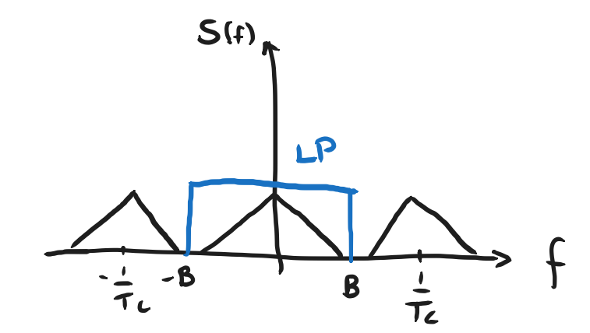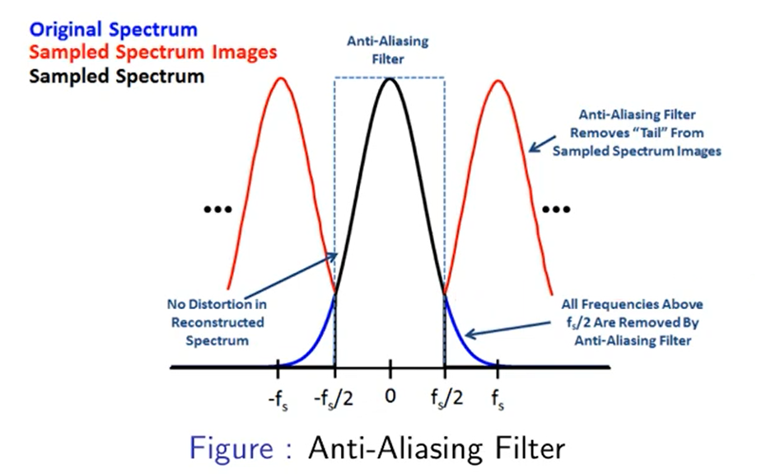

- Low-Pass Filter (LP) - cuts frequency above a certain threshold, only low frequencies can pass

Aliasing
- If conditions for reconstruct the full signal from the sampled one are not satisfied, aka:
  - Nyquist criterion (f_{c} > 2B [aka T_{c} < 1/2B]) unsatisfied
  - Not band limited (B < ∞) unsatisfied
⟹ we have aliasing: overlap between higher and lower frequency components ⟹ impossible to extract only the original central frequency of the spectrum
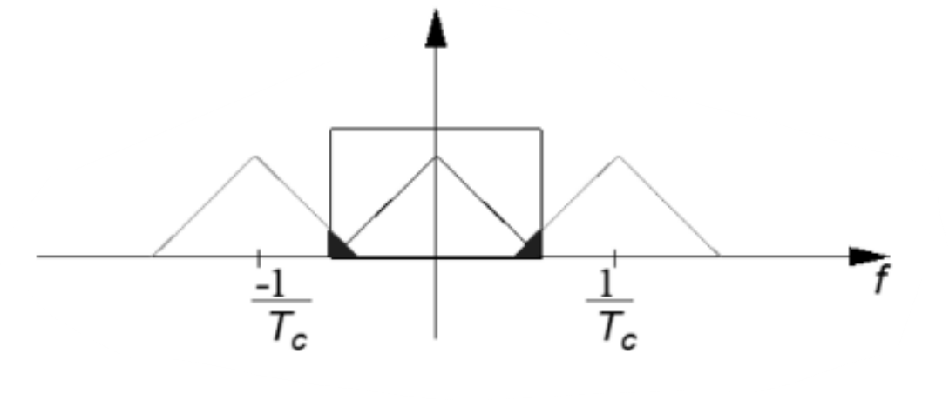
- Usually is better to band limit first, and then sample
- With aliasing we still have distortion (since we cut the signal) but distortion is halved (reduced by a factor of 2)

- If Nyquist criteria are satisfied ⟹ no aliasing 🙂
- If Nyquist criteria are not satisfied ⟹ use low-pass anti-aliasing filter to attenuate high frequency components of a message signal that are not essential to the information being conveyed. Use anti-aliasing filter, it guarantees the least distortion
- Antialiasing filter have bandwidth B_{LP} = f_{c}/2 = 1/2T_{c} (aka sampling frequency)

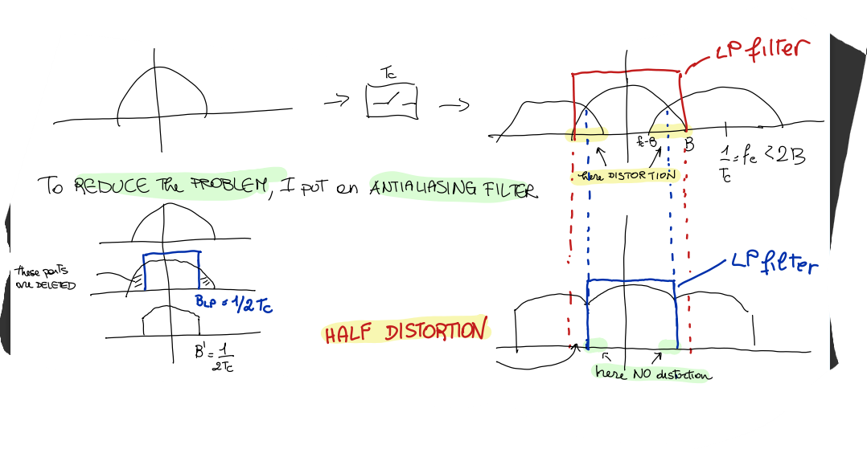

Aliasing
- Occurs when a continuous signal is sampled at rate that is not sufficiently high to capture its frequency content accurately
- Usually happens when continuous signal is less than twice the maximum frequency of the signal (Nyquist criterion)
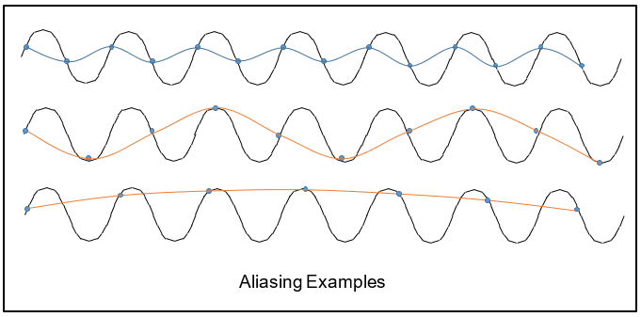

Multiplexing signals - PAM vs AM
- Sampling allows multiplexing in time → multiple signals can be transmitted at the same time, without loss of information
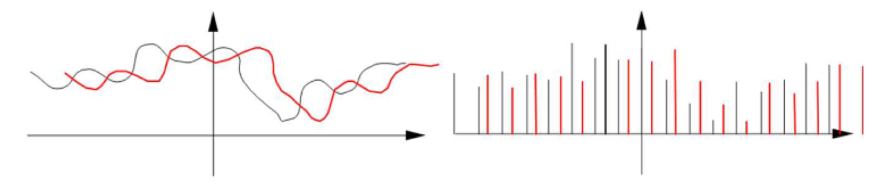
- If we hadn’t sampled two continuous signals on the left, they would have overlapped → impossible to transmit them at the same time without loss of information 🙁
- With sampling → transmit multiple signals simultaneously by interleaving their samples 🙂
- Pulse (amplitude) - modulated (PAM) signal: signal obtained by multiplexing in time

Some differences between PAM (Pulse Amplitude Modulation) and AM (Amplitude Modulation):
AM (Amplitude Modulation):
- multiplexing in frequency done by multiplying each signal by a cosine at different frequency (which generates a frequency shift in the spectrum)
- It occupies some frequencies for all the time
PAM (pulse-amplitude modulation)
- Multiplexing in time done by using different time inputs for each signal
- Occupies all the frequencies for some time instant
- Modulation is done in the base band (not shift the signal on a different frequency, unlike AM which do the shift)
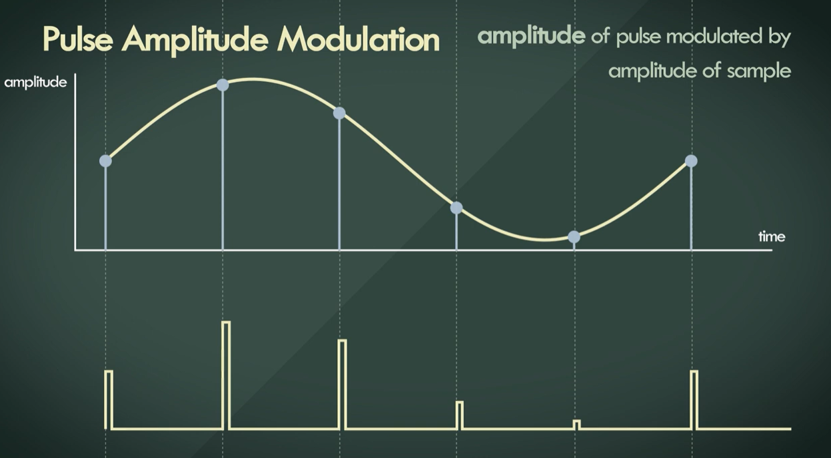

Ideal vs Real Sampling
- Truly instantaneous sampling is not possible
- Two possible case that aim to approximate ideal sampling (two formulations of sample signal, but with rect instead of δ, since theoretically use Dirac function, but in real-world applications is not possible, so we use rectangular functions):

Long sampling:
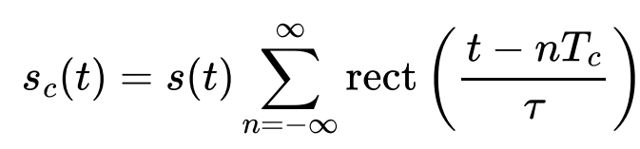
- Multiply the continuous signal by a series of rectangular pulses
- Each rect function is centered at nT_{c} (T_{c} is the sampling period) the width of each rectangle is 𝜏
- You have the entire signal and you do the sampling (like recorded tv program)

Sample and hold:
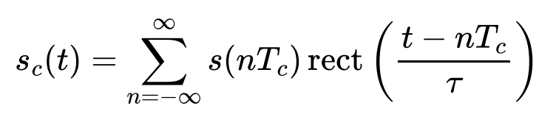
- Sampling the signal at discrete time points s(nT_{c}) and holding (or maintaining) the sampled value over the interval defined by the rect function
- Create a piecewise constant signal where each sampled value is extended over the duration 𝜏
- You sample the signal while “its moving” (like live tv program)

The spectra of long sampling and sample and hold are respectively:
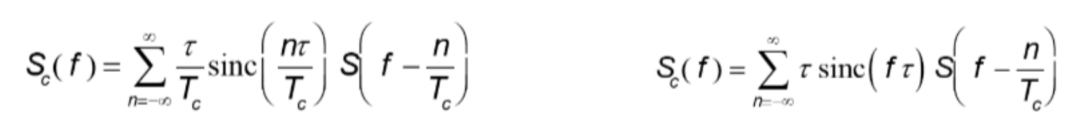

Noise
- Sampling is useful (we need to satisfy only the Nyquist criterion)
- Sampling has an amplification effect on noise 🙁
  - Continuous signal s(t): if we have disturb only at one time instant the problem is only for that time instant.
  - Discrete sampled signal s_{c}(t): if we have a disturb at a time instant it is a problem for the whole signal
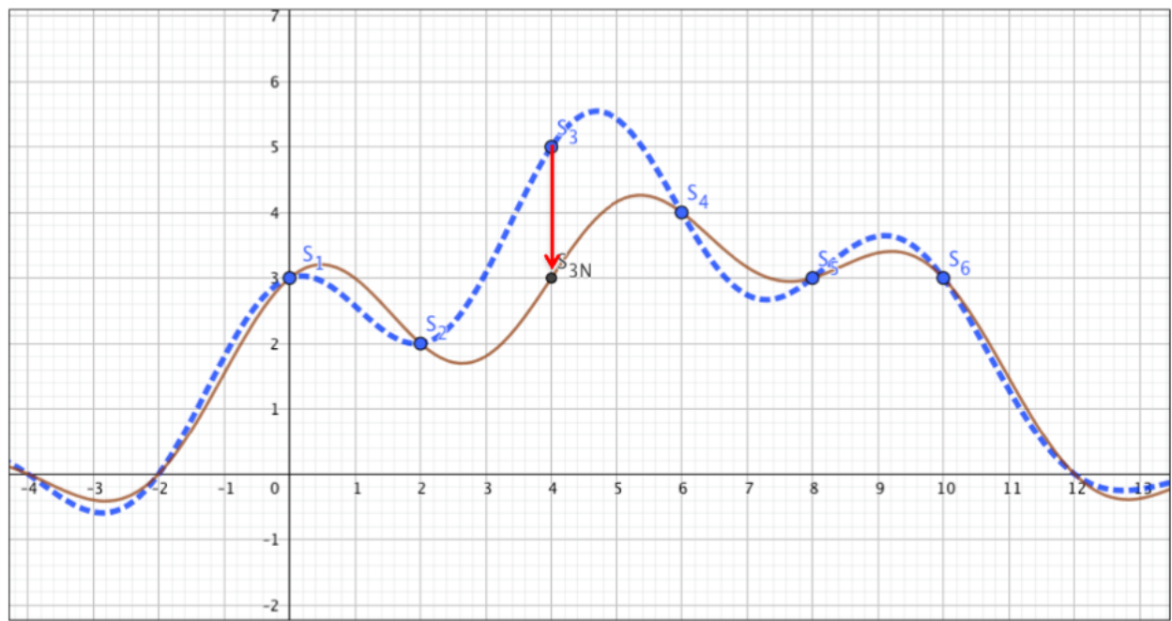
- Only the sample s₃ has a problem, which gets reflected on the whole signal.
- Such noise in point 3 causes only the sinc in point 3 to change → changes the whole shape

⟹ sampled signal are less robust to noise 🙁
⟹ We need to apply quantization to let the signal take only some discrete integer values

Quantization
- Sampled signal is very affected by noise 🙁 since information is encoded by the pulse height
- We quantize the signal → assume only fixed N values for the amplitude of the signal, instead of the whole set of values R
- Quanization: used to recognize if there is noise: if signal can assume all values, I do not understand when there was an error, but if values are limited I can see it
- Example: if a signal can only take values 0, 0.1, 0.2, … then if at a time t I have s(t) = 2.54 ⟹ there must be noise (the signal can assume value of 2.5 or 2.6)
- Quantization cause a distortion of the signal 🙁 ⟹ all the values in between get mapped to the fixed values I have chosen
- Quantization process degrades the signal and causes what is received to be slightly different from what is transmitted (even in absence of noise)
- With quantization I cannot go back to original signal
- It is possible to do sampling first and then quantization (or the other way around)
5. Quantization - Digital Audio Fundamentals

Quantization error E_{q}(t)
- Quantization error aka quantization noise
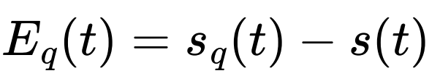
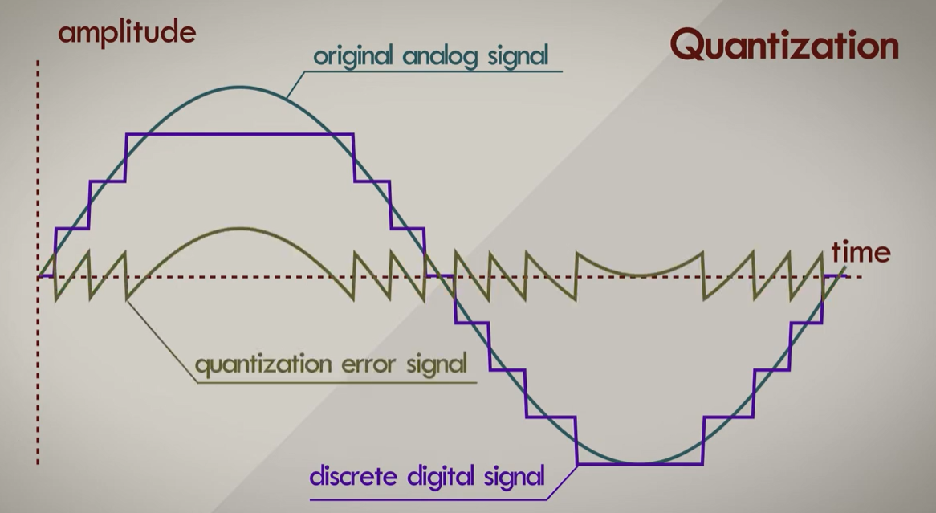
- Δ: can be sees as the resolution of the “quantized” signal ⟹ if Δ = 0.1 s(t) can take values 0, 0.1, 0.2, …
- Δ = R/N
  - R = range of all possible values of the original signal
  - N = number of intervals
- I can recognise an error if I have a value on the 2nd decimal (like 2.54)

- E_{q}max: maximum quantization error (how large is the signal with respect to the number of intervals I choose): is related to how much the signal is large with respect to the number of intervals
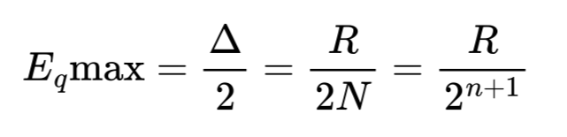 (hypothesis that N = 2^{n})

- E_{q}%: Percentage quantization error (related to absolute number of intervals): related to the absolute number of intervals
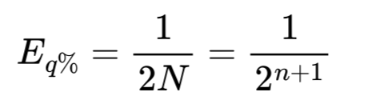 (hypothesis that N = 2^{n})
- P_{EQ}: Power of quantization error (equal to the variance σ², and expresses how far I am from the mean value of $\underline{E}$_{q} = 0): how far I am from the mean value
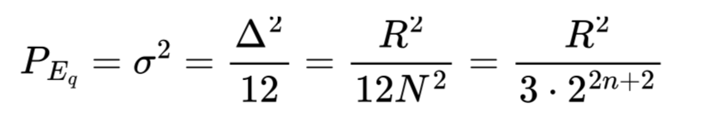 (hypothesis that N = 2^{n})

There is a trade-off between:
- The maximum noise I can recognise with quantization
- The maximum quantization error I get

- There is always a trade off between distortion and sensitivity to noise:
  - < N levels → > sensitivity to noise 🙂 BUT > distortion 🙁
  - > N levels → < distortion BUT 🙂 < sensitivity to noise 🙁

⟹ If I decrease the possible values of the signal’s amplitude (N) I can detect noise faster (since “more values”) but I also have more distortion (since the amplitude are move to further away values)
⟹ If I increase the possible values of the signal’s amplitude (N) I have less distortion (the amplitudes that are in the middle are moved to closer values) but am less sensible to noise (“smaller gaps”) 🙁

Digital signals - encoding - Pulse Code Modulation (PCM)
- Pulse Code Modulation (PCM): convert analog signal into digital data
- If values of a quantized signals are known to the transmitter and the receiver ⟹ we can transmit only the index (“digit”) of the value, instead of the value itself
- The receiver can go from the index back to the sample value, and then from the sampled signal we return to the estimated source signal (since quantization was applied so I can not go back to the original signal)

- To get from analog signal to digital signal
- Sampling ⇐ convert analog signal into discrete signal
- Quantization ⇐ convert discrete signals into digital signal (aka in predefined set of values)
- Encoding ⇐ quantized sampled to digital data

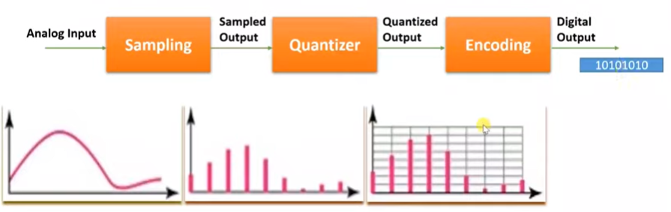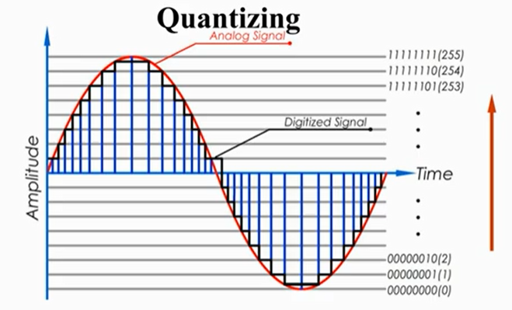

- 8 bit depth ⟹ 2⁸ = 256 levels (N). Each level is associated with a specific 8-bit value

- Advantage → different signals can be encoded and transmitted with the same object (500 indices of the interval)
- Pulse Code Modulation (PCM): process of extracting a digital baseband signal

- For the indices to be transmitted, an analog signal is used again
- Indices are encoded by symbols
- Symbol → signal in time, whose duration is the symbol time T_{s} which represent an information
- If the information is a bit (0 or 1) then symbol time is equal to the bit time T_{b}

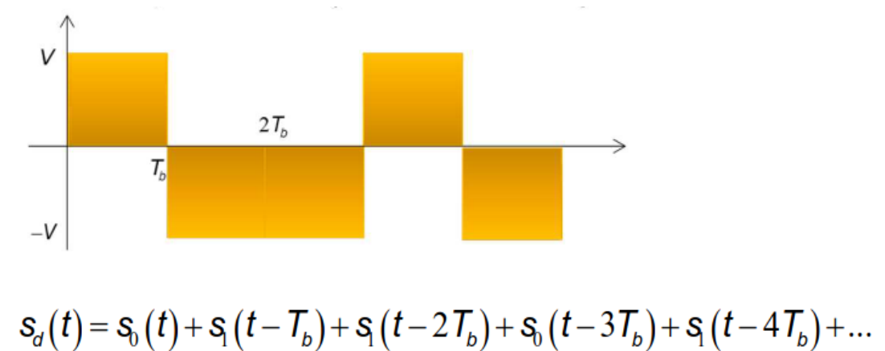

- Analog signal representing a digital signal
- Different from pure analog signal, since I know the shape (values) so it is simpler

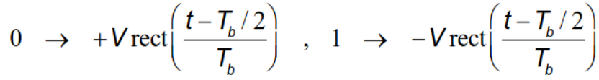
- Sequence of 0s and 1s which is a binary number, used to encode the encoding level number (index) of the current value of the quantized signal
- The analog signal transmitting the digital data will be a succession of rectangular signals, which in turn can be written as a succession of copies of a function of the form g(t) (a rectangle with height V) multiplied by +1 and -1

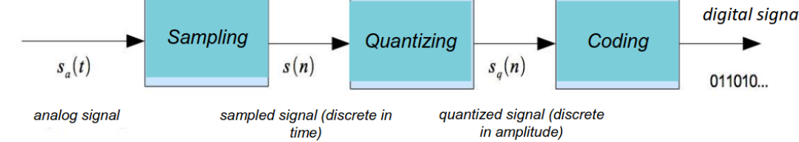

⬇️_____________________________⬇️

Digital sequences
- They are discrete-time, digital signals
- Usually are discrete in amplitude (aka quantized)
- Different ways to sample a signal
- Examples of simple sequences are: unit sample and unit step

Simple sequences: unit sample (delta) [dirac]:
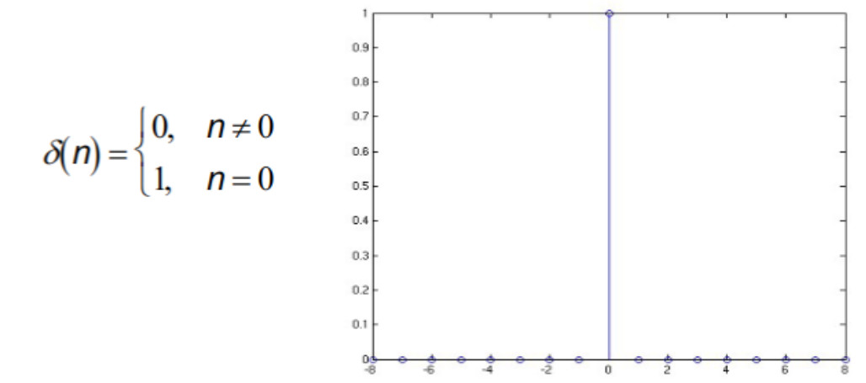

Simple sequences: unit step:
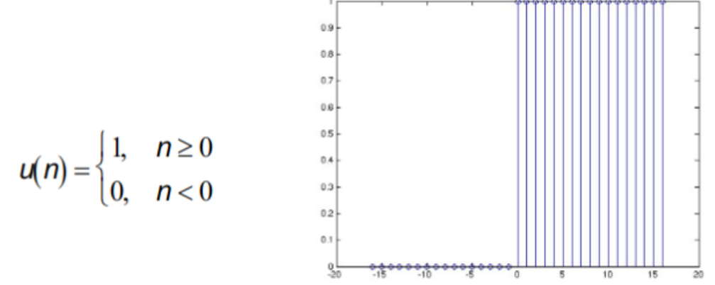

- A sequence is periodical with period N if:
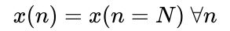
- The sampled signal of a periodic continuous signal may be not periodic (it depends on the chosen sampling period)

- Energy of a digital sequence x(n):
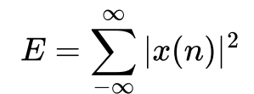
- Digital sequences have following properties:
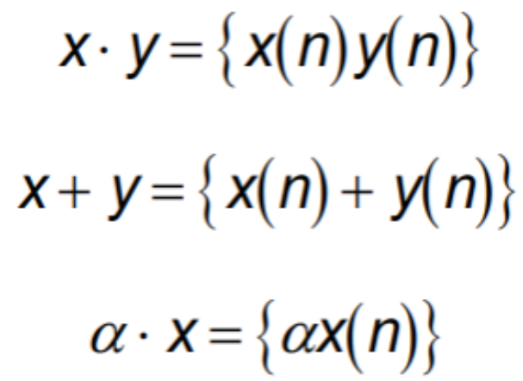
⟹ the product of two sequences is equal to the product of their respective elements
⟹ the sum of two sequences is equal to the sum of their respective elements
⟹ multiply a sequence by a constant is equal to multiply each element by the constant

Linear systems
- It is a system that can be described by linear equations, having superposition principle
- Response of the system to the linear combination of some inputs is given by the linear combination of the responses to the single inputs ⟹ in a linear system, the response of a linear combination of the inputs is equal to the linear combination of the responses of the single input ⟹ in a linear system, output of a linear combination of input is equal to the linear combination of the single output
- Linear Time Invariant: if the response to a time shifted impulse is the same response, shifted by the same amount

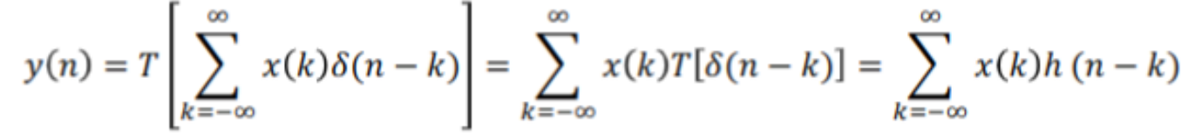

- Convolution: important operation used in linear system, it simplifies the relationship between input and output of a system
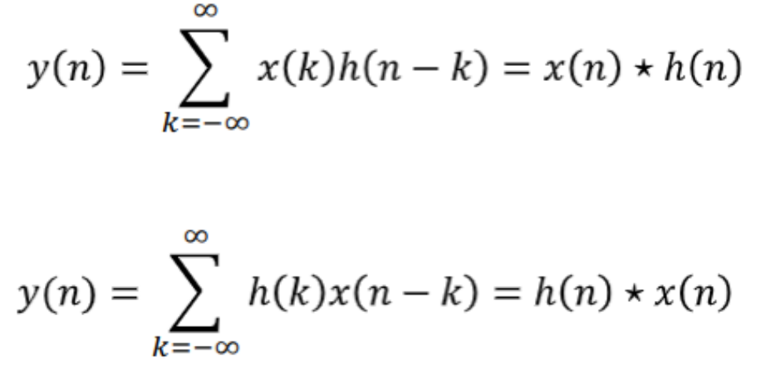


Stability - Bounded Input Bounded Output (BIBO)
A system is stable: when any bounded input produces a bounded output ⇔ aka BIBO stability criterion

LTI systems stable if and only if:
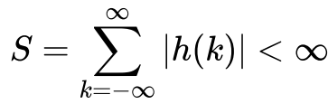
- Aka if the inverse transform of the transfer function should have a converging sum (integral in the continuous case) so that the output (given by its convolution with the input) would be finite (aka bounded)
- Formula can be seen as impulse response, given that convolution of a filter over an impulse signal δ(n) is equal to the filter itself

- Two conditions for a system to be stable:
1. input should be bounded ⟹ |x(n)| < M
2. impulse response should have a finite value

Causal Systems
- Causal system: system that does not response before the input is applied (not causal ⟹ output arrives before the input 🙁)
- If for any n₀, its output at time n₀ depends on the input only for n ≤ n₀.

- LTI system is causal iff the impulse response is 0 for any n < 0 ⇐ since we start applying the input at t = 0 the response should be null for times before that
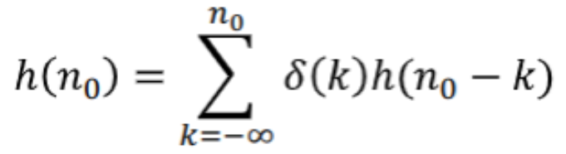

Linear Difference Equations
Subset of LTI system for which the equation holds

- Output of the system y(n) is a linear combination of past output y(n-k) values along with present and past input values x(n-r)
- a_{k} and b_{r} are filter coefficients that define the system

- Such systems are not all causal
- With no additional information the difference equation does not define uniquely the input-output relationship of the system
- Any solution of the homogeneous equation (right side of the equation = 0) may be added to a solution and still be a solution

If the system is causal we specify the following initial conditions:

and we defines an explicit relationship between input and output:
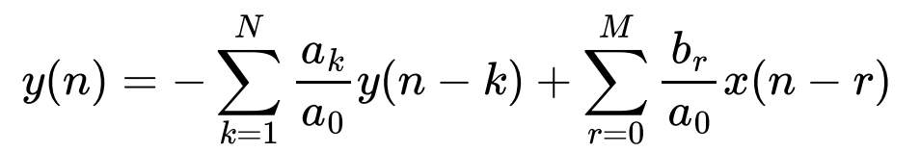

Example:
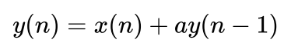
If we have an impulse response x(n) = δ(n) we have:
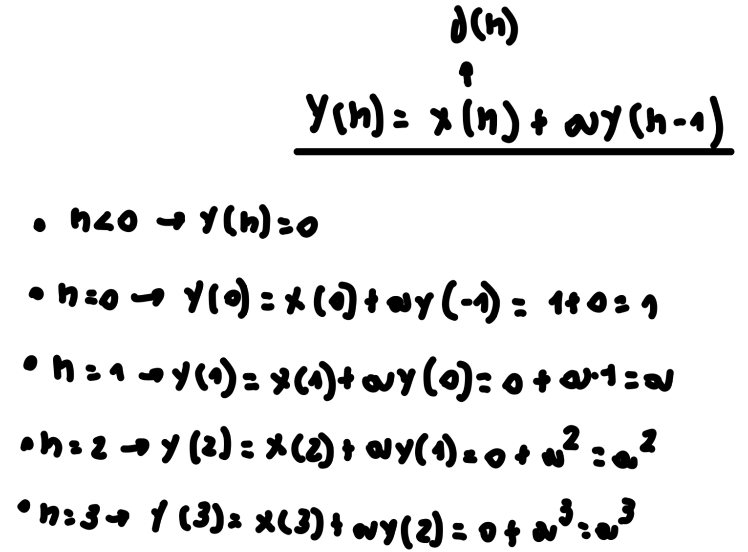

IIR (Infinite Impulse Response) and FIR (Finite Impulse Response) Digital Filters
Infinite Impulse Response (IIR) systems satisfy equations like


Finite Impulse Response (FIR) systems do not have the term of the past output values y(n - k) (its order N is 0) and satisfy the following:
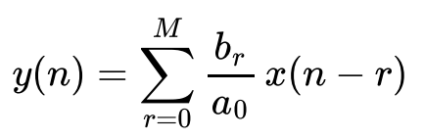

Recap:
- Infinite Impulse Response (IIR): output depends from past output
- Finite Impulse Response (FIR): output do NOT depends from past output

FIR can be implemented via convolution sum:
- In the continuous case we have
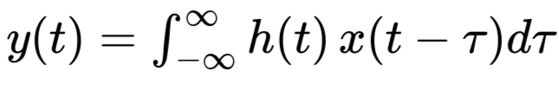

- In the discrete case
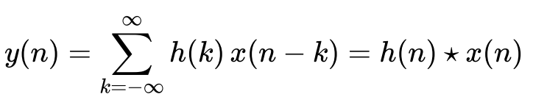
- h(k) represent b_{r}/a₀

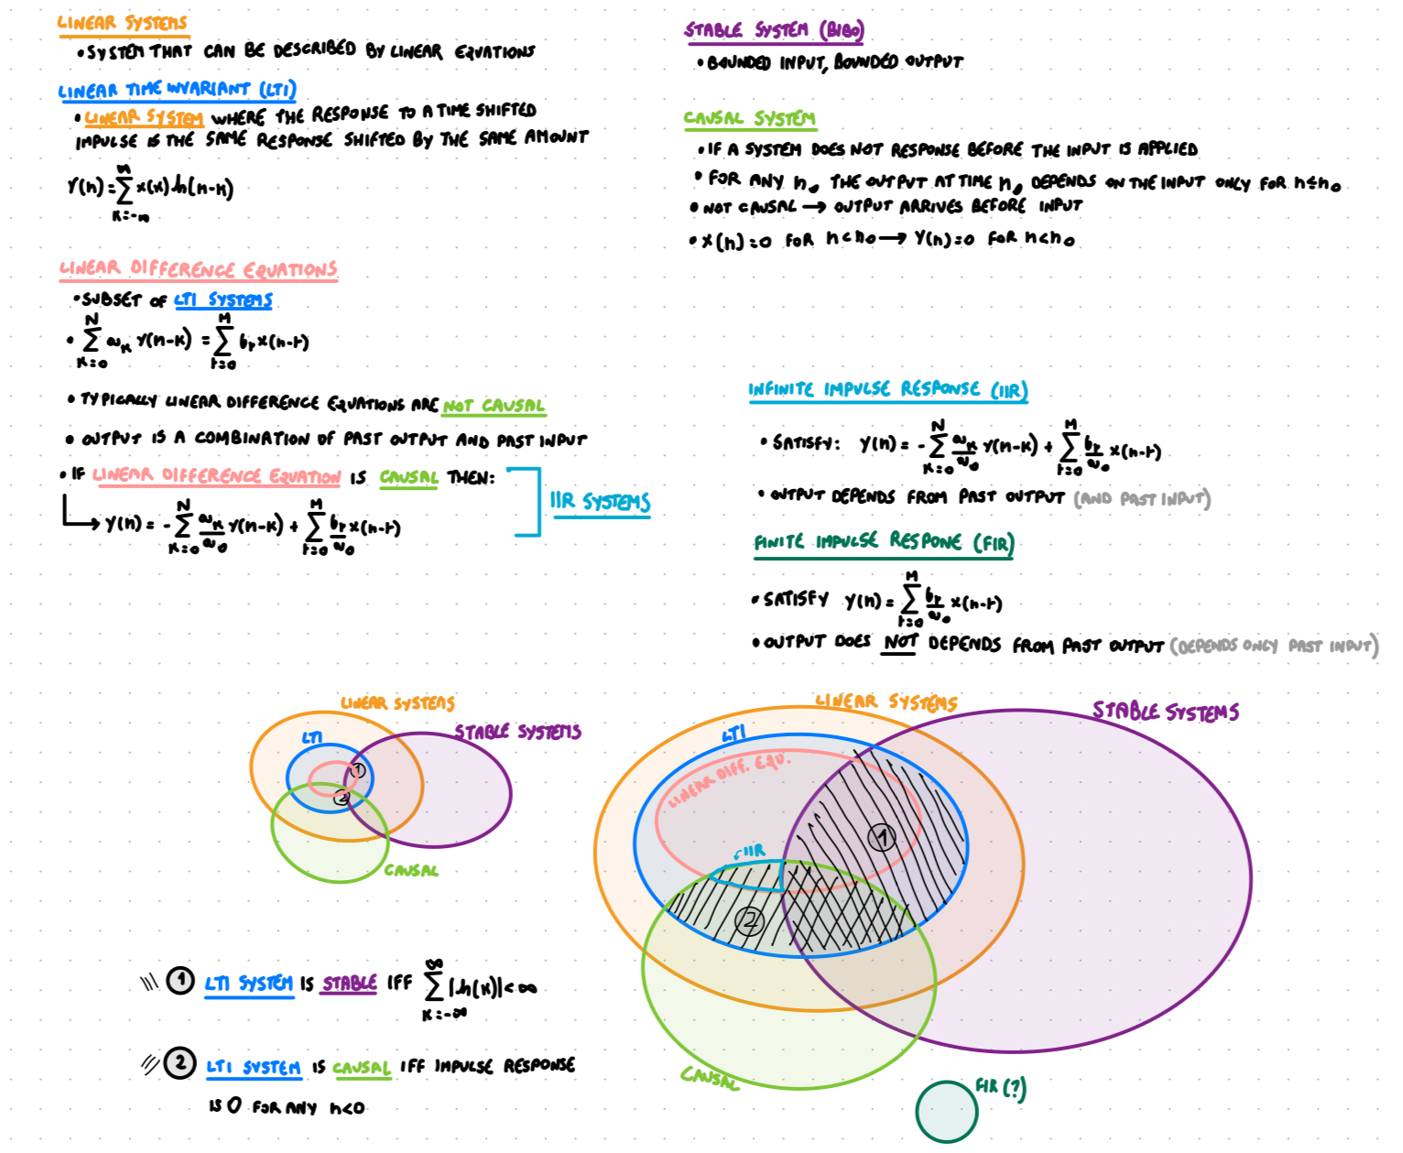

⬆️_____________________________⬆️

Discrete-Time Fourier Transform (DTFT)
- Convert a discrete signal (aperiodic) from time domain to a continuous signal frequency domain (periodic with period 2π)
- What is important is that we go from discrete time domain to continuous frequency domain and from aperiodic signal in time domain to periodic signal in frequency domain

- The discrete fourier transform is equivalent of the continuous fourier transform for signals known only at N instant separated by sample times T
- For discrete-time systems/signals h(n), the DTFT is given by:
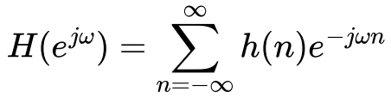
where ω is the frequency variable (equal to 2πf)

For DTFT to exist, it must be converging ⟹ stability (BIBO) is a sufficient condition for the existence of DTFT

Formula very similar to standard Fourier Transform, with n in place of t, and integral in place of the sum.

Recap: fourier transform


DTFT formula (unit sample response of a system) is called frequency response of the system and it defined how a complex exponential is changed in amplitude and phase by the system

DTFT function H(•) is a continuous function in ω (frequency domain) and has period equal to 2π

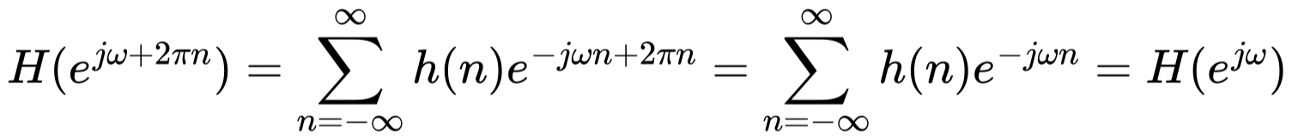
[proof that DTFT in frequency domain has period of 2π]

Inverse Discrete Time Fourier Transform (IDTFT)
- With DTFT we can recover original signal from the transform via inverse operation (IDTFT)
- H can be seen as Fourier Series (since it is a periodic function) in ω with period 2π by taking c_{n} = h(n)
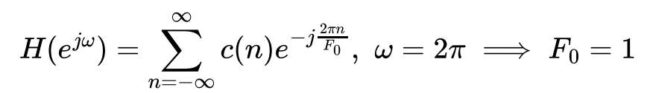 [ F₀ = 1/T₀ ]

Recap: before we saw DTFT as


- Each c_{n} corresponds to h(n) and can be obtained from Fourier series antitransform formula:
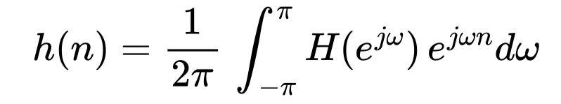
h(1) = c₁, h(2) = c₂, …

Recap: fourier series

 ⇔ [ very similar to the formula above with period 2π ]


For example, for ideal low pass filter ( filter that keeps only lower frequency values below a certain value ω_{T} ), we have
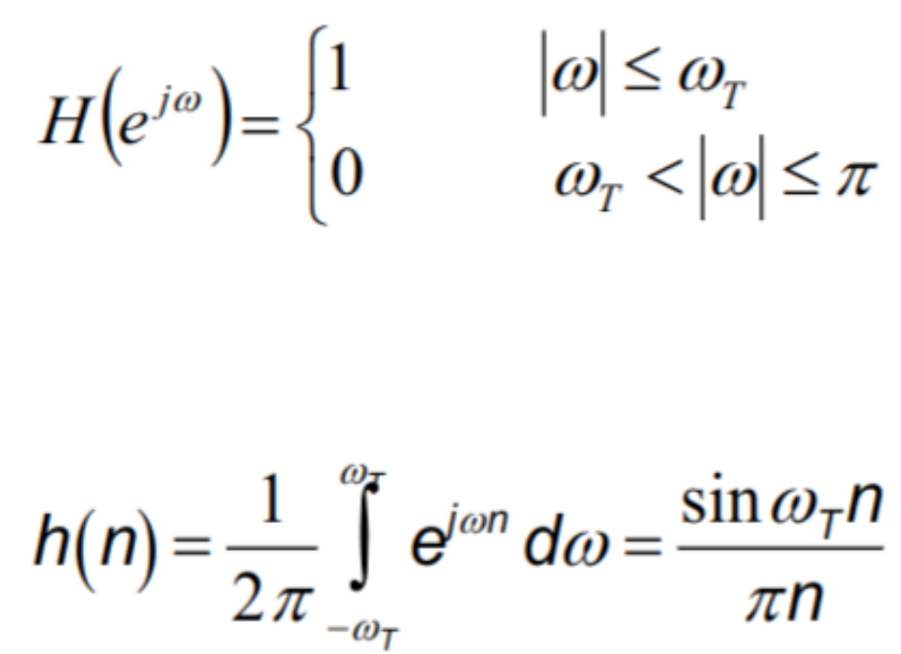


DTFT for systems
Since we know DTFT and IDTFT, we can express systems as convolution of the digital signal values or simply as products of their DTFT transforms (as convolution is equal to the product in the transform domain, convolution theorem)
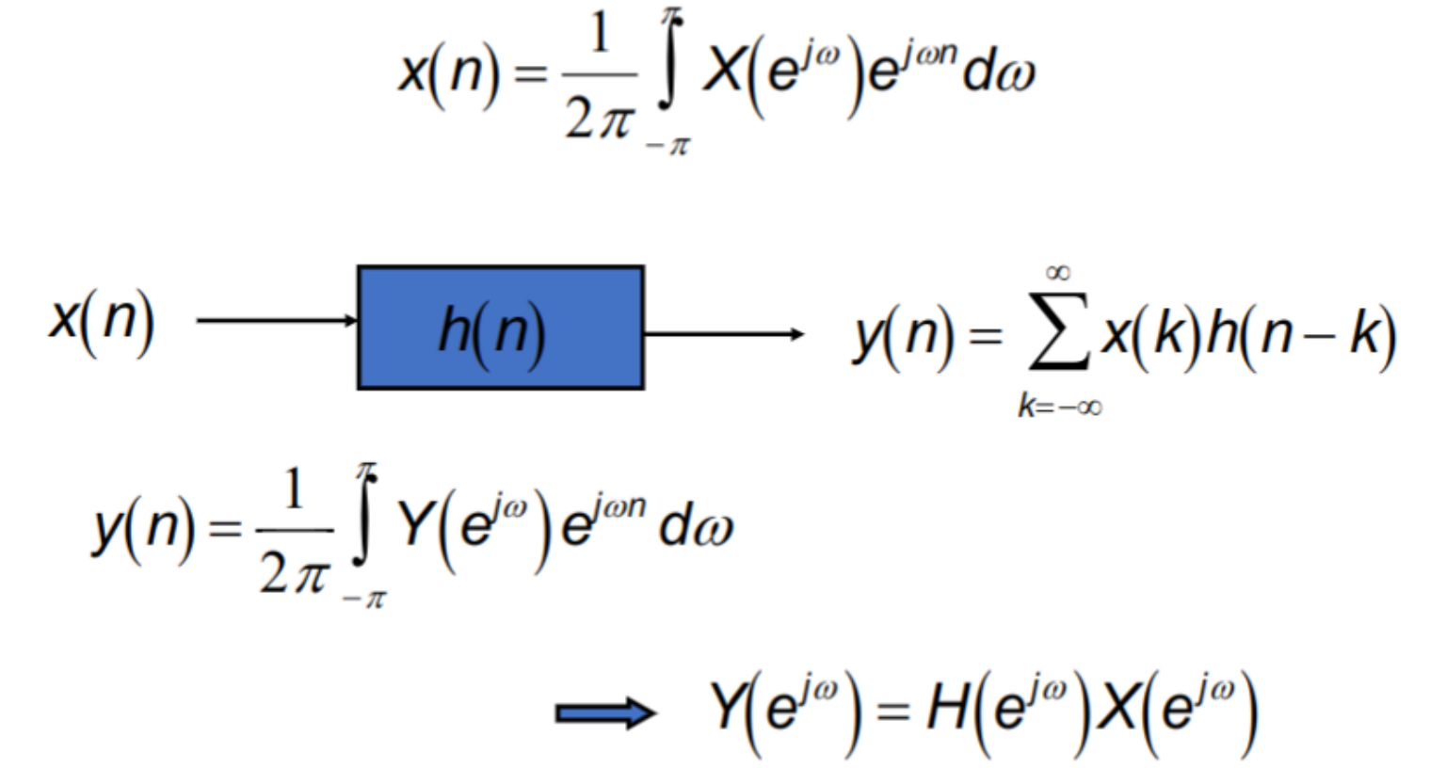

Given a input x(n) if it is pass through an impulse response it gets y(n) and the transform of the output is equal to the product of the transform of the input with the transform of the impulse response

Properties of DTFT
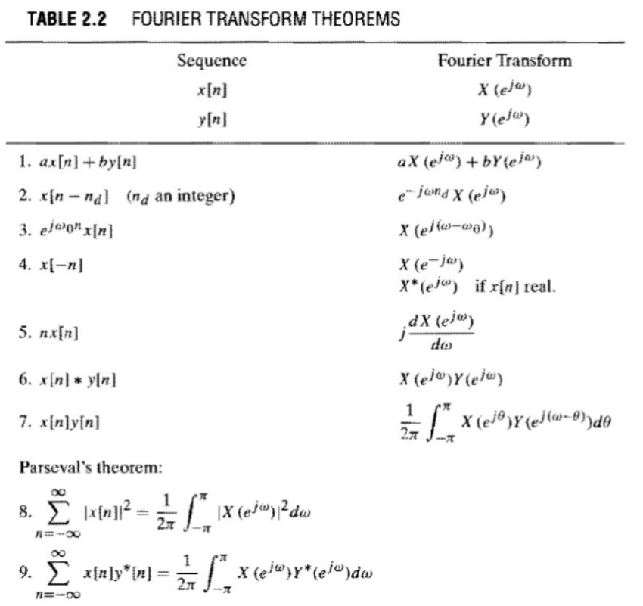

Z-Transform
- Is a generalization of the DTFT
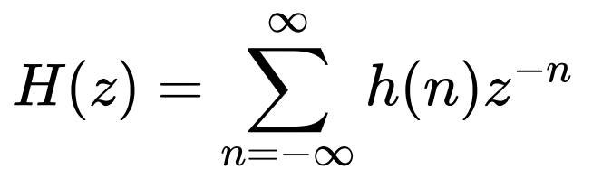
- z is a complex variable
- if z = e^{jω} then the z transform is equal to the DTFT (with ω=2πf)
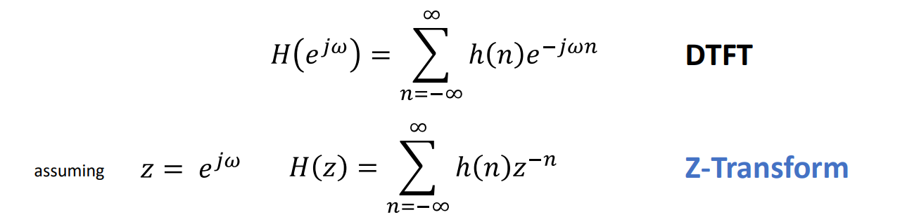
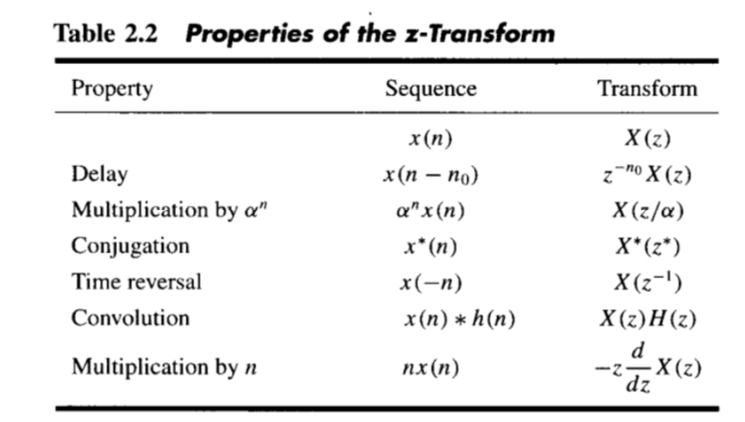

Discrete Fourier Transform (DFT) and Fast Fourier Transform (FFT)
RECAP: DTFT (Discrete-Time Fourier Transform)
- Convert a discrete signal (aperiodic) from time domain to a continuous signal frequency domain (periodic with period 2π)
- What is important is that we go from discrete time domain to continuous frequency domain and from aperiodic signal in time domain to periodic signal in frequency domain
- 
⟹ Since the signal in the frequency domain is periodic and continuous with period 2π the next step is to sample the signal in frequency domain to make it discrete.
- You convert ω with 2πk/N where N is the number of sampling you want to do in frequency domain (take samplings at different values of k where k is from 0 to N-1)

- In many cases I do not have an analytic function but I have some values at discrete locations (samplings) ⟹ I want to compute the fourier transform of the data (break the data I have in a sum of sine and cosine)
- The Discrete Fourier Transform (DFT)

- Z-transform (and DTFT) is a function of continuous frequency ω, so we could not use it for digital signals ⟹ use DFT
- To use it for finite length frequencies, we can sample the frequency

- Sample the points around the unit circle, which is represented by the e^{jω} term:
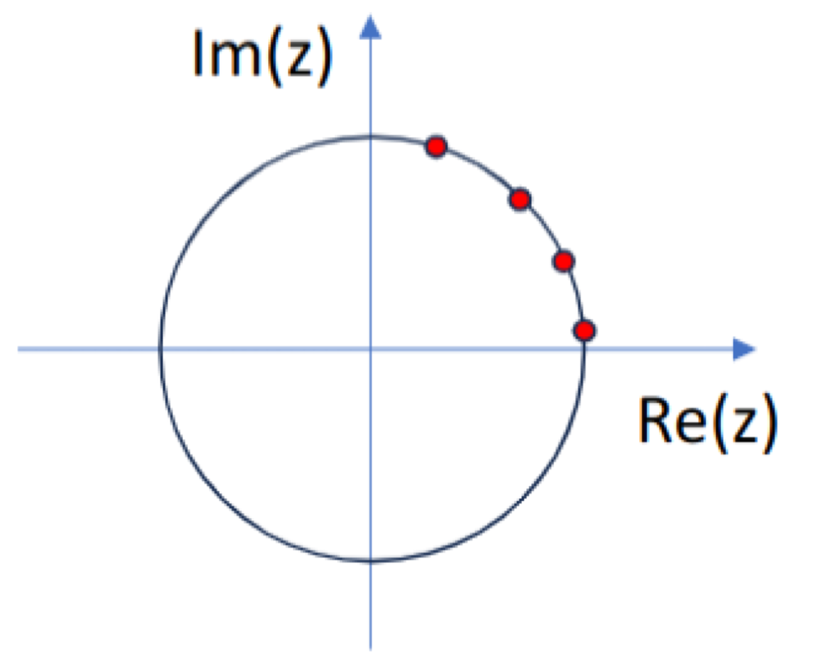

- Then we go from e^{-jwn} to e^{-j2πkn/N} where 2πk/N is the sampled frequency term

- We obtain a function called Discrete Fourier Transform (DFT), function of an integer variable k. For a finite length digital sequence x(n), which is 0 outside the interval [0, N-1], we have following N-point DFT:
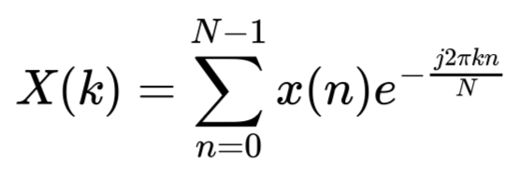

- We can define the Inverse Discrete Fourier Transform (IDFT)
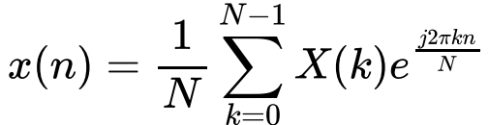

- Analogous to Inverse DTFT formula.
- In this case we have periodic transform, sampled at N equally spaced frequencies between 0 and 2π.

- Fourier transform of a periodic sequence is itself a periodic sequence

- Fast implementation of DFT is called Fast Fourier Transform (FFT)

Transfer Functions of Filters
- We can go from frequency domain to the time domain with a transform
- We can also represent a LTI system (aka filter) with different notation
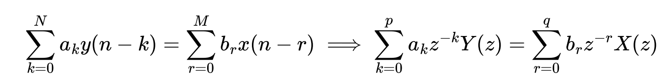
- Z- transform of system function h(n), 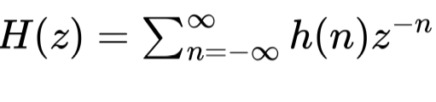is called Transfer Function (of the system):
